**Python Notes Review**

* **.items( )** in python refers to returning a view object. The view object contains the key - value pairs of the dictionary as tuples in list.
  + The .items( ) are recalling in the list so basically returns the **key and values**.
* **.keys( )** method returns a view object. The view object contains the keys of the dictionary as a list. The view object will reflect any changes done to the dictionary.
  + It’s very simple this returns the **keys** of the dictionary's
* **.values( )** method returns a list of all the values available in a given dictionary.
* Something worth mentioning here is when it comes to working with lists and individual parts such as whether an item is in a list or not.
  + if “ pakistan ” **not in** user_profiles.values()
    - Something that you can tell from this line of code is that the **not in and .values** the user_profiles is basically a dictionary.
    - values are basically the Y to X in dictionary's { key : values}
    - Something else that I wanted to add was that you are not typing **is not in** you also **can not** type **is not** name_dictionary because it is WRONG syntax.
  + if “ password ” **in** user_profiles.values( )
    - Same thing goes for here the thing you need to address is the ***in*** users_profiles
* Understanding the **set vs sorted:** the thing to know here is that set is being used to characterize all the repeating elements in list and sorted is basically sorting out the elements in the list.
  + 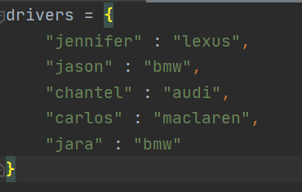
  + 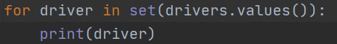
  + 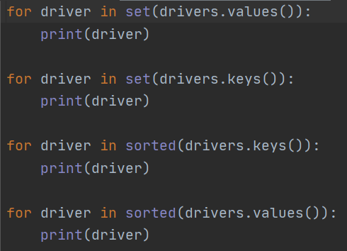
  + So a summary of the 4 for loops is that 1: you're basically identifying all the set driver values 2: you're basically identifying all the set of driver keys. 3: You're basically sorting out all the driver key. 4: You're basically sorting out all the driver values.
  + Something else that you need to know, driver is basically acting as the key unless specified otherwise. Meaning if you were to print driver without specifying any key or values then it would just print the key.
* Something else that I wanted to cover was the **range( )** – is used to generate a sequence of numbers over time starting from 0 by default and increments by 1 by default and stops before a specified number. For example look down below

numbers = list(range(0,10))  
print(numbers)

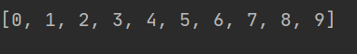

* + Something I want you to notice here is that the value range of what it's doing is its starting from 0 and ending at 9. The reason why it's ending at 9 even though you had put 10 that’s something that you need to keep in mind that range does.
  + Another thing that you want to keep in mind is that initially whatever number you start with in (X,Y) that’s usually the number the list starts off with just the ending number is going to be one less so be sure to put number + 1.
  + So for example if you need a list that up to 50 therefor your going to state up to 51 so it reaches 50 when it comes to working with range( )
* The next thing that we are going to cover is when it comes to working with for loops and range functions and how they work together.

for numbers in range(20):  
 print(numbers)

* + What this code is doing is that it's going to be printing all the way up to 19 look down below. Even though the code is stopping at 7 what’s happening is that the code is basically starting from 0 and ending at 19.
  + 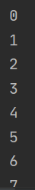

* The very next thing that we are going to be covering is how dictionaries can be integrated within lists and the use of for loops. Something worth mentioning here is spacing when it comes to python, spacing is very important in the next code you will understand why. Another thing that you want to keep in mind is the difference between list and dicts and not treating them in the same way.
* So before we begin, the first thing that we are going to look at is called **Slicing -** to slice an object what you're doing is modifying a sequence when it comes to python.

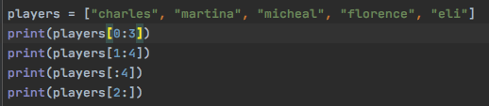

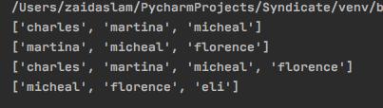

* Something very simple that we covered was that the list begins in the number that you stated with and ends one less then the number stated after the colon. That's the simplest way you can remember this.

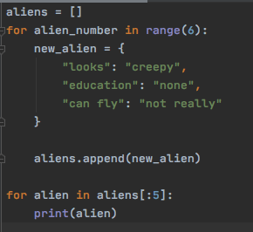

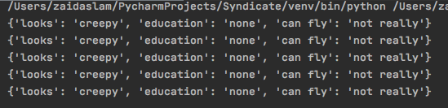

* In the beginning you can see that we start off with an open list and it's called aliens, what we are going to do is input a dictionary within the list 6 times.
* The thing that you are wondering is when it comes to the for loop is…
  + How come we are using a new variable called **alien_number?** (why can't we just use the same variable called new_alien that we specified for our dictionary)

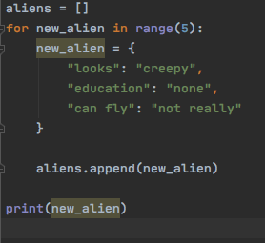

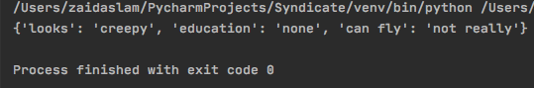

* + - **Local variable -** is a variable that is either declared within the function or is an argument that is passed to a function.
    - **Global variable -** a variable declared outside the function or in global scope is known as global variable.
    - The reason why the new_alien is highlighted is because it's giving an unbound local variable error that ties into the global & local variables. This is basically saying that you have mentioned a variable however you have not bounded it to something. Another thing that you want to consider is the very definition of what local & global variables and how this ties into the whole question of yours.
  + How come it is printing out 5 times shouldn't it print out 4 times because of the whole N-1?

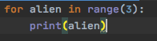

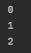

* + - So take a look at this code for example you might think it's the N-1 rule and alien should be printed 2 times, however that is not the case because alien will still be printed 3 times. The only catch is that alien will start at 0. The reason why this is so important is because it makes sense when printing out the dictionary and it prints out exactly the amount of time is specified on the range function.
    - The thing that you need to take into consideration is when working with lists and how the numbering is very different and originally lists start with 0 not 1. That is different when being compared to this. Rather what you are doing here is basically printing out the dictionary the number of times you have specified. Take a look at the example that you did earlier in the beginning that talked about this concept.
    - 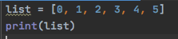
    - This is how python sees a list. It's weird because we would see the list as more so [1, 2, 3, 4, 5] but no that's not the case because any list in python **starts** with 0. I think the reason why it was kind of hard to grasp was because in my mind I kept thinking that the list begins with 1 rather than 0.
* Something that we are going to be covering next that is really important is working with dictionaries, modifying elements that are already pre-existing within the dictionaries. Another thing that we have to take a look at before we get to any manipulation (that we forgot to cover) is the very simple thing of adding different elements within a dictionary separately.
  + 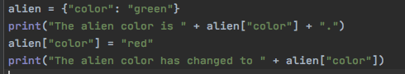
  + 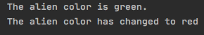
    - So right off the bat you can see the proper way of inputting elements within a dictionary. Notice how you have the name of the dictionary first and then you **key** and thus changing it by inputting another **value.**
* Something that I really wanted to mention was how to use if and else statements when it comes to working with dictionaries. The cool thing about doing this is that you can check individual items within a dictionary to see if the dictionary meets the condition that you want it to meet.
  + 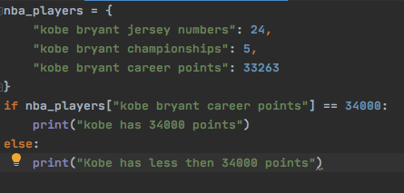
  + 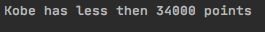
    - Take a look at how the dictionary is being checked within the if statement as you can see its **nba_players[“kobe bryant career** **points]** format. This is the basic format for accessing elements within a list or dictionary, check out this other example that shows something similar rather with a list instead.
    - **loops -** the basic structure to perform iterations several times.
    - **for loops** - iterations that you know how many times they will occur.
      * for variable in range
    - **while loops -** run an iteration unless specified otherwise.
      * while true
      * if is used more frequently with this loop
      * you can terminate a single iteration using **continue** but the loop keeps running for the next iteration to be executed.
      * **break** command terminates the iteration and the loop itself
    - When it comes to the loops the indentation plays a vital role because it tells python which elements are within the loop. Another thing that you want to understand is the term **iteration,** think of iteration as your running laps in a circle until you reach a mile. **Each lap that you run is called an iteration**
  + 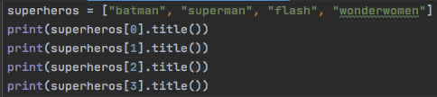
  + 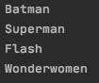
    - So this program is really simple and self explanotory but it's basically working with each element within a list. The reason why I wrote this down was so that you can see the difference between a dictionary and list and how the same approach is being applied.
* The following program that you are going to be seeing is worked in khan academy and it basically teaches you important concepts when it comes to for loops.
  + 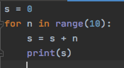
  + 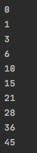
    - Right off the bat you can notice that initially **s** has been defined as 0 meaning that s holds the value 0, if you were to call s it would print 0. (think of a variable as a bucket because it's holding something).
    - Next thing that you need to understand is how the for loop is going to be working, it is basically running iteration all the way up to 9 and not 10 starting with 0. Another thing that is also important to understand is that **each** **iteration** is now **known** as **n.**
      * [0, 1, 2, 3, 4, 5, 6, 7, 8, 9] = n
    - So the next thing that you need to understand is that there are two things going on.
      * First in the beginning s is holding a value already as 0 and it runs through the iteration or loop the first time and the first n is 0 therefore it's adding up the value of n + s (in this case the first initial 0). This step is what I call unloading the bucket where the first value of sum is being used is being run through the loop to get the cycle started.
      * Secondly the thing you have to know is that after the first iteration you have a new s as 0 even though the original s was already 0 (that's why when you look at the second image you can see 0 because of the loop). Now let's look at the second iteration/loop, it's the **new value** **of s + n** so meaning that 0 that is in the second image plus 1 (next number in list of n.) So therefore the new s is now equal to 1.
    - After you understand this it's very simple the for loop is repeating the same thing it's getting the next value of n adding it to s and getting a new s and printing it and is going to keep running until it reaches 9. So next one will be 3 = 1 + 2 where 3 becomes new s and 1 was the previous s and 2 is the n from the list.
* So now we are going to go back to the original code that we had written with the alien and we are going to be writing something similar to it. However there is going to be one twist which is that we will be changing some elements within the dictionary.
  + 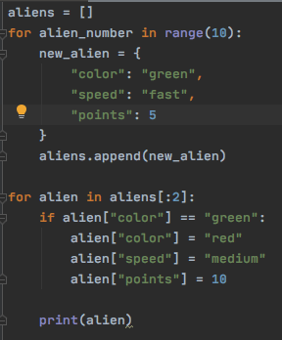
  + 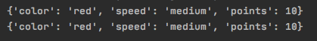
    - **if statements**- python uses if statements for decision making, it runs a body of code only when the given condition is True. When you want to justify whether one condition is true then other then you will be using the if statement.
    - **else statement**- contains the blocks of code that executes if the conditional expression in the if statement resolves to 0 of false value.
    - **elif statement**- allows you to check multiple expressions for true and executes a block of code as soon as one of the conditions evaluates to True.
    - **variable-** is a reserved memory location to store values
    - **conditional statements-** are features in programming language which perform different computation or actions depending on whether a program specified boolean condition evaluates to true or false.
    - So the technical thing that is happening here is that in the code that we are running there is a secondary for loop and within that for loop we have specified a given if condition. The reason why will be covered in the second bullet point
    - So notice first we are using a for loop which is responsible for going into the list of dictionaries in aliens and modifying for new_alien @ [0, 1] places. The next thing is the given if condition which is responsible for saying that *hey if this is true then do that.* Which is exactly what is happening the -if condition is specifying for new_alien up in the places that I specified and modifying the values for the keys [“color”], [“speed”], [“points”].
    - Something that is considered a rookie mistake when using conditional statements is that you have to be sure to terminate them when done establishing them for example ending the conditional statement with :
* Before we keep going further in the code we are going back to look at something very simple when it comes to if, elif, else statement.
  + 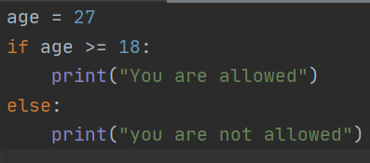
  + 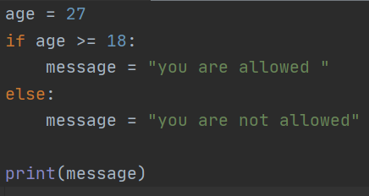
    - This is a simpler way of writing this code where instead of writing a print statement, what you're doing is writing a variable called message and storing what you want to say. You are then recalling the message and whichever statement is True its printing out that value of message.
    - So this is the traditional way of writing the code where you're setting a variable to a number and giving if and else statements to it however there is a cleaner way to write this code.
    - **ternary operators** - is a way of writing a conditional statement in python. As the name ternary suggests the python operator consists of three operands. Put it very simply the ternary operator is a way of simplifying the if and else statement.
  + 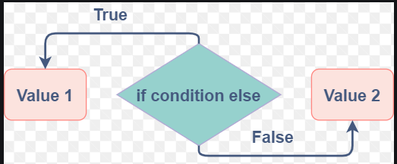
  + 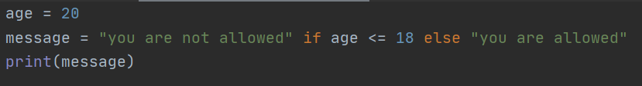
    - So notice this is ternary operators in the beginning you are specifying a value for message followed by if and else statement and ending with a string. The cool thing about this code is that everything is on one line and it makes sense when you read it out almost as if you are writing in english. The other thing that I want you to pay attention to is that in this line of code you don’t need any terminator ( : ) because usually for a conditional statement you would need some form of terminator but when doing it this way you don’t need it.
  + 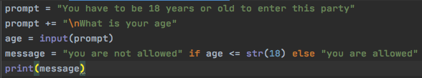
    - So if you were to look at this code you can see how this whole concept is being applied it makes the code look more cleaner and on-top of that it’s easier to write.
* The very next thing that we are going to be talking about are logical operators and how they also play an important factor when it comes to the conditional statements / python in general, not just boolean.
  + - **logical operators -** are used on conditional statements either True or False. They perform Logical **And**, Logical **Or**, Logical **NOT**
    - logical **and -** if both the operands are true then condition becomes true.
    - logical **or -** It returns objects instead of True or False values when it tests Python objects. This means that the expression x or y returns x if it's evaluated to true, and otherwise returns y (regardless of its truth value).
    - logical **not -** used to reverse the logical state of its operand
  + 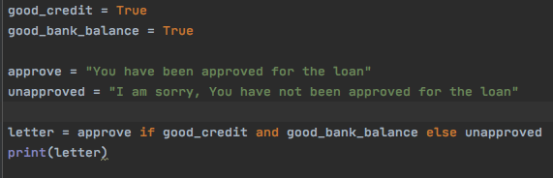
  + 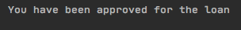
    - As you can see from this code you have stated two boolean values that have **both** been set to **True**. Now the format is something I came up with so don’t know if its proper etiquettes. The thing you have to take away from the code is how **and** is playing a role since both the statements are true therefore the if statement is running.
  + 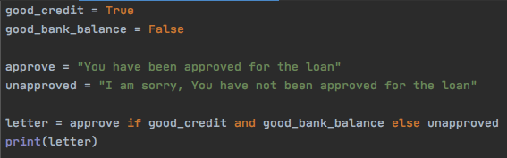
  + 
    - Since **one boolean value** has been set to **False,** now the if condition is not going to run because the logical operator **and** requires both to be True therefore you will have to use another logical operator.
  + 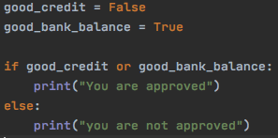
  + 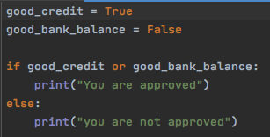
  + 
    - Something that you want to pay a great deal of attention to here, is look at the True and False. When using the or operator it doesn't matter in which stance what is True / or False. It's almost like telling python (“hey if either or is true or not”). In the next paragraph we are going to be talking about the not operator.
  + 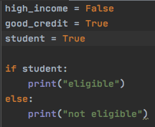
  + 
    - So this statement is really self explanatory, since student boolean value is True the if statement is being executed.
  + 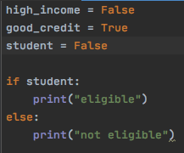
  + 
    - This statement is also self explanatory as well since the boolean value for student is False therefore the else statement is being executed.
  + 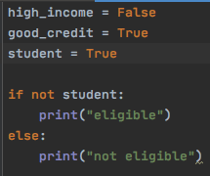
  + 
    - So before we begin this code, you have to understand that the not operator inverses the value of a boolean. So for example if you were to say **if student: print(“eligible”)** this code is really self explanatory because you are basically saying is student = True then print this statement. When you are putting the **not operator** you're basically reversing the statement and telling python that if **student = False.** So in the next line of code you will see how when we put the boolean to False and the code on the if statement will run instead. Something that I forgot to mention the reason why the else statement ran was because the value of boolean student was True.
  + 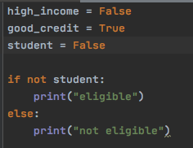
  + 
    - So looking at this code it's basically saying if value of student = True therefore run the appropriate statement in this case if statement. Another important thing that I want to add is that in the second line of code if not student still means false, it's not like where you think “oh the boolean should be inverted this time as well” Therefore in conclusion the thing that you need to know here is that since student is False and your telling python if not student means if student is False which it is therefor. It's kind of weird because you see False and then you see not and it throws off your mind completely.
* Now we are going to be talking about the same concept but there is a cleaner way to write the code and it's just like ternary operators that we covered above however since there is an or statement you would have to do something different in the code because you also have the boolean value of student that you would want to incorporate in the code.
  + 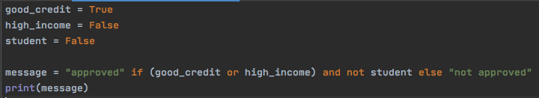
  + 
    - So looking at this code you can tell that this code is basically a ternary operator something that you want to pay attention to this code however is that since we have **or** logical operator instead of and therefore we are using ( ). Something else that we are going to focus on is how the ternary operator where adding another conditional statement and stating **and not student.** When writing the code this way it is so self-explanatory and very readable.
  + 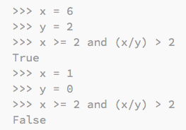
    - This whole technique is known as **short circuit programming -** in other words when the evaluation of a logical expression stops because the overall value is already known it is called short circuiting the evaluation. Another thing to know is that the program is evaluating the expression from left to right.
* The next thing that we are going to talk about is **chaining comparison operators**, what this does is that it makes the code look cleaner and even more easier to read
  + 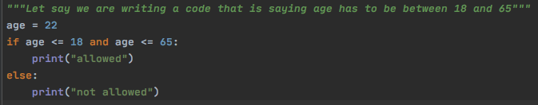
  + 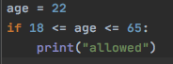
    - This is what you call chaining comparison operators, something worth paying attention to is that this is simple mathematics saying that age has to be between 18 and 65 and thus print the conditional statement if age is between those numbers.
* So the next thing that we are going to be covering are back to some basics and they are for loops we are going to be covering in more detail.
  + 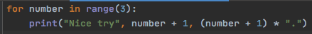
  + 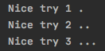
    - Something new that I learned by looking at this line of code on the for loop was pay close attention to the print statement you have 3 different recalls the first is printing the statement “nice try”. The second is printing the value of number + 1 because how we covered that number would have been [ 0, 1, 2] therefore 1 is simply being added to the value of number. The last thing that is happening here is like “PEMDAS” in a way you're telling python that it works with the ( ) first in this case adding 1 to the value of number [0, 1, 2] and thus multiplying it by the character “.”
    - Something else that I want to mention in this code is that pay attention to (number + 1) * “.” So that is actually responsible for the periods at the end the thing that I had overlooked was the fact that think of each statement within the print( string, calculation, calculation) and when you look at the print statement think of it as a column where so (Nice try , 1 , .) So basically whichever column it is in the calculation is going to be done appropriate towards it.
  + 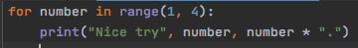
  + 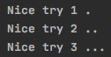
    - So looking at this code it's the same scenario however the only difference in the code is that you are starting at 1 and ending at 3 therefore you do not need to add one.
* Something else we are going to cover is how to square numbers using for loops and how adding another parameter within our range function and how it affects the code /outcome.
  + 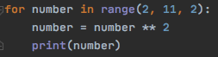
  + 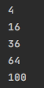
    - This code is really self explanatory but the important thing to look at is the print statement it's basically saying [ 2 , 4, 6, 8, 10] and those numbers squared.
* So the next thing that we are going to be taking a look at is the **indentation** - because python uses indentation to indicate a block of code. So the next code that you will be looking at the importance of the indentation and how each indentation of the code will work with each other. This part is also referred to as the **for else** block.
  + 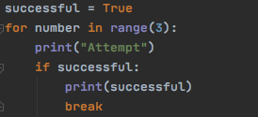
  + 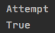
    - When looking at this code I made a rookie mistake where I was not paying attention to how the different parts of the code were reacting because of the indentation. So for example look at the idenation it's almost like it's telling a story starting with the for loop and ending with the break statement. The thing to know here is iterations, like what python is doing is that it's running the program step by step. You have to think of python when it's running a program. It's running it one lap at a time only at lighting pace. For example initially we state a boolean value to a variable which plays a vital role later on. Next thing we do is we call on a for loop which is responsible for printing “attempt” 3 times. However the thing we need to know is how the if statement and break statement stop the program from printing the attempt 3 times. So looking at the **if statement** you're stating that if successful = True therefore print successful and then **break.** For example when I was looking at this code I was thinking to myself “oh it's going to print attempt 3 times and then break”. That's not the case, take a look at the next scenario and see it in more detail.
  + 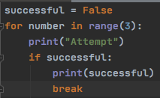
  + 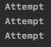
    - So looking at the next scenario what we can see is that we have set the boolean variable to False this time. So what is going to happen in this code is that “Attempt” is going to be printed out 3 times because the if condition is not being met therefore its not reaching the break statement and rerunning in the loop till its specified iterations. The thing to take away from all this is how important it is to understand indentation and iterations and how they play a whole factor in deciding the outcome of your code. Another thing is to take it step by step and understand what is happening in the first cycle because when you can tell what's happening in the first it merely repeats itself X amount of times.
  + 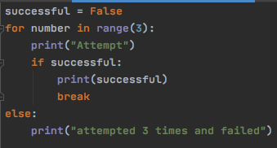
  + 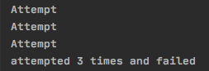
    - Take a look at this code the only thing to introduce here is we added an else statement, since successful was False and it did not meet the True requirement therefore it didn’t meet the if condition and went to else. The idea to understand within the code that how if and else statements can play a factor in for loops and how they interact with one another and also boolean and break.
* Now before we move to nested loops we are going to be covering strings in more detail because an example is going to show up in loops that are going to require this knowledge.
  + 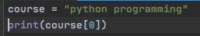
  + 
    - **function -** is a reusable piece of code that carries out a task. Think of a remote: different buttons do different tasks.
  + 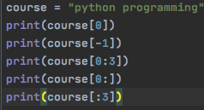
  + 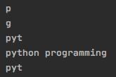
    - **square bracket notation** - is used to access a specific position at whatever index that you want to recall. Something else that you need to know is that the python strings are indexed at 0 meaning the count starts from 0. The examples above are pretty self explanatory at this point but you get the idea.
  + 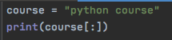
  + 
    - So something that I wanted to address was that I learned about this [:] but it really had never occurred to me that this is basically copying the code from 0 till it ends. I was making the mistake of memorizing the code rather than understanding the concept.
  + 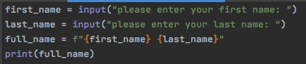
  + 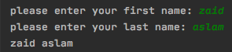
    - This is what known as formatted string take a look at how its being formatted **f “{} {}”** I initially didn't really know of this format but the advantage of this format is let’s say you are writing a code like this where you storing a value of string within a variable and you need to then put those variables containing the string together now if you were to write the code it would initially look like this **full_name = first_name + “ ” + last_name** now this isn’t wrong but there is a cleaner way of writing this code. When you do it the way described above you no longer have to write the space in between which can be tedious if you're writing a huge code.
  + 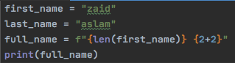
  + 
    - Something else that you want to pay attention here is that when using formatted string you can put any value of expression within the curly brace.
  + 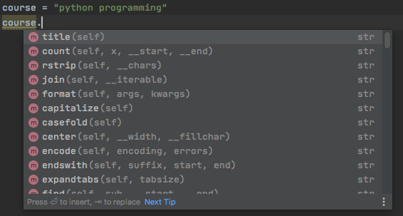
    - **methods -** is similar to a function except it is associated with objects / classes. So think of it this way: everything in python is an object and objects have functions that we call methods that we can access using the dot notation. Take a look at the course that is an object and all the pink m are functions that we call methods.
* The next thing that we are going to be covering is **nested loops -** a nested loop is a loop within a loop, an inner loop within the body of an outer loop. How it works is that the **first pass of the outer loop triggers the inner loop which executes to completion, then the second pass of the outer loop triggers the inner loop again. This repeats until the outer loop finishes**. Before we start breaking this code down, we are going to be looking at a more readable example then this one to truly understand what is going on.
  + - So right off the bat I have some questions,
      * Why are nested for loops so important?
      * In which program will you be using nested for loops?
  + 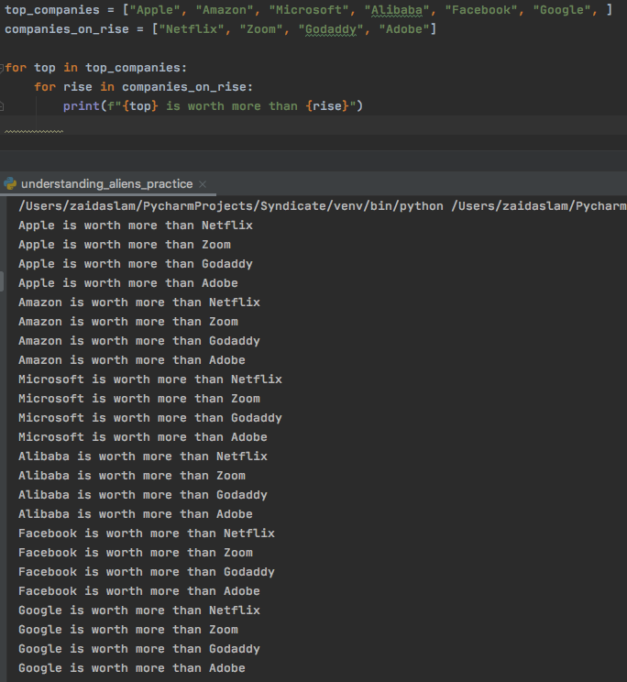
    - So take a look at this code one question that I had was when will you use a nested loop? and this is a good example of when to use nested loops. As you can see there are two lists of top companies and the second list contains companies that are on the rise. Looking from here the first for loop we are specifying each item within the list and the second for loop we are doing the same procedure after that we are running the cycles. So what's going to happen is the first for loop is going to get its one item and link it to all the items within the second list (**one to many**). You might be wondering why does it do that? The answer is parent and child loops. The parent loop is the one that is not indented however the child loop is the one indented. Therefore when python is running the for loop it's attaching one parent item to the remaining child item therefore because once again indentation is playing a huge factor.
  + 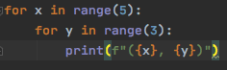
  + 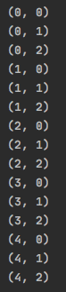
    - So when looking at this code we can see that x is going to be [0, 1, 2, 3, 4] and y is going to be [0, 1, 2]. After learning how the nested for loops work we can see what's going on here each item in the parent for loop is being linked to the remaining item in child for loop because of the indentation. Some other key words that I forgot to mention was iteration that each lap runs through that is linking the parent and child for loop.
* The next thing that we are going to be talking about are **iterables-** An iterable is any python object capable of returning its member one at a time permitting it to be iterated over in a for loop. Familiar examples of iterables include list, tuples, strings any such sequence can be iterated over in a for loop. Another thing to know is iterable means iterations.
  + 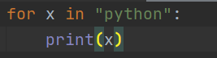
  + 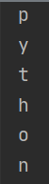
  + 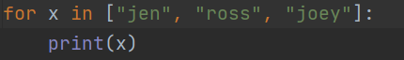
  + 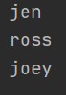
  + 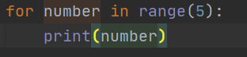
  + 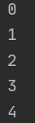
    - So this is very simple it's basically saying each iteration you will get one character and print it.
* The very next thing that we are going to be looking at is **matplotlib** - is a plotting library for the python programming language and its numerical mathematics extension Numpy. It provides object oriented API for embedding plots into applications using general purpose GUI tools like tkinter, wxPython, qt etc… Another thing that we need to cover is **what is pyplot?** is a collection of command styles functions that make matplotlib work like Matlab. With that being said the next thing that we are going to be looking at is how this works down below.
  + 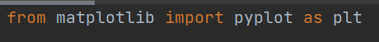
    - So the thing that I want you to take away from here is pay attention to the plt, your calling matplotlib and from there your calling pyplot and your giving it an alias as plt.
  + 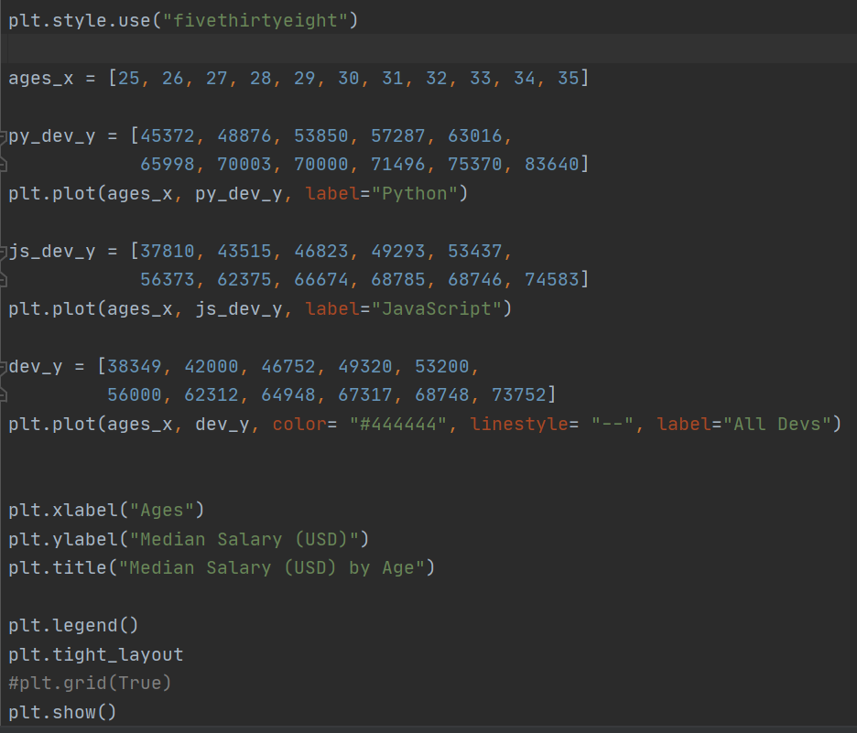
    - So there is a lot happening here but understand its really simple pay attention to ages_x these are going to be our x values when we plot out our graph. Something that you need to understand is the 3 different developers there are python, javascript, regular developer. So before we begin to tackle this code down we need to go into more detailed ages we have set from 25-35 for all of our developers this is our constant difference however the salary. Each age has its own salary. Notice every step we are calling plt.plot that means pyplot.plot, which is telling python that “hey matplotlib plot this” This is what is referred to as methods in python that tell python to do a specific task. Now we are going to be talking about arguments notice within the parameters we have label= “Python”. So a thing to take away from this is that these are known as arguments and arguments basically serve a purpose in python to the benefit of the method. Something that i want to mention is the way you were to plot the graph that how they would portray so for example how you started with py_developer if you had started with js_developer then js_developer would have been printed first in python. SO in conclusion it is really simple tbh i remember when i first did the graph i was memorizing and was like there is too much to memorize however after understanding the concept it makes more sense and it's really simple and self explanatory.
  + 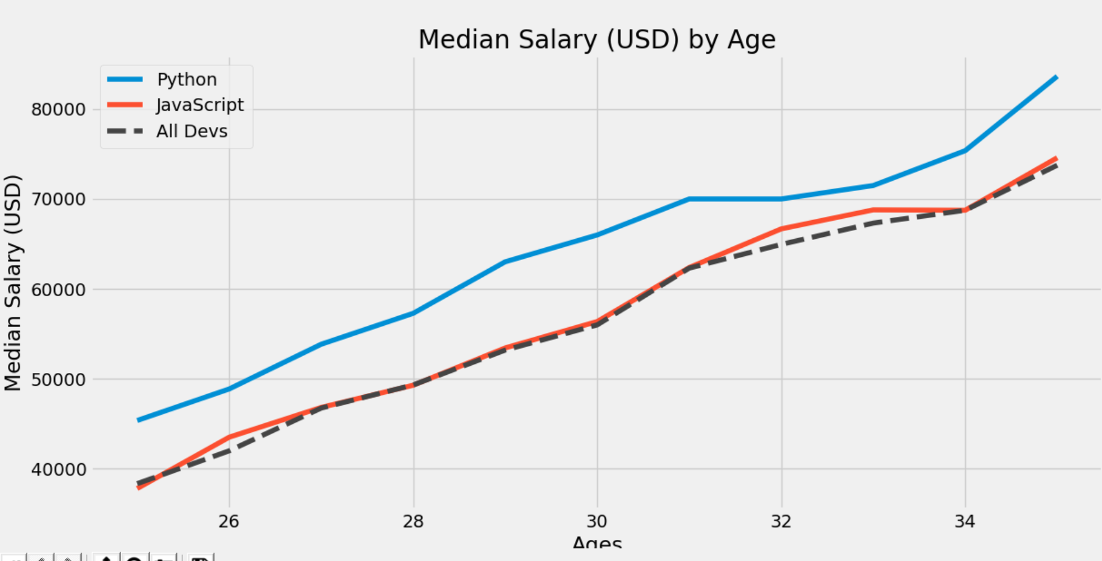
* Something that we are going to be talking about is **mutable -** objects can be changed after it has been created. **immutable** - object can not be changed after it has been created.
  + 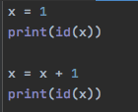
  + 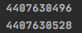
    - So take a look at this code what the **id -** what this is doing is that its returning the address of the memory location where x references. **integers, strings, booleans in python are immutable** so in the beginning it was given the address ending in 496 but notice how when you restated x the address was given ending in 528 because what python did was that it saw since you are working with integers and they are immutable therefore we will give you a new address and what ends up happening to the old address it gets removed.
  + 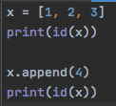
  + 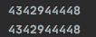
    - **lists are known as mutable** because when you are getting the address for the list using id you can see that its the same number ending in 448. The reason why I wanted to point this out was that. The thing to take away from this code is that since your putting 4 into the list therefore the list then it is printing out the same id.
* Something else that I want you to pay attention to is Falsy values take a look at the values and think why are these called falsy values and why are they important?
  + 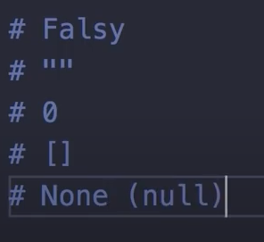
    - The reason why these are called Falsy Values is let's say if you had set a variable to any one of these values it will return False because if you were to look at these 3 you can see that they all have no value nothing in other words representing empty that's another way to describe it false = empty. Something that i want to mention is that list are mutable but the reason why this list is Falsy is because the list contains nothing in it therefore the list is considered Falsy.
* The very next thing that we are going to be talking about is the difference between types and list. **Tuples (immutable)**  - lets us chunk together related information and use it as a single thing. Tuples support the same sequence operations as strings. **Lists(mutable)** - data structure in python that is mutable or changeable, ordered sequence of elements.
  + 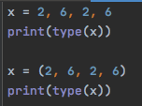
  + 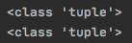
* Now that we know what a tuple is we are going to look at arguments and then input tuples within. So take a look at the code down below there is a lot that is going on.
  + 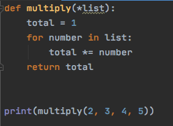
  + 
    - So we defined a function called multiply within it we passed a parameter called list the reason why we have * is because that is get all the items within our **tuple** and input them within our parameter. So what that means is when you see 2, 3, 4, 5 those are the items within our tuple and thus we are inputting them within our parameter value had we not done this then in our parameter we would have 4 different parameter values. Notice the next thing that we are using is a for loop and were basically looping through the tuple. So there is some detail moments going on first we specified total = 1 this gives us an initial value of total then we are running a for loop within our list. Then comes the most important thing total *= number what this is referring to is total = total * number and we have to do some math. So we know our value for total = 1 and number is basically 2, 3, 4, 5 the elements within our list. The very first sequence we put 1 * 2 and our new total = 2. The next sequence is 2 * 3 = 6 (total * number). the sequence after that is 6 * 4 = 24 which then becomes a new total. Lastly its 24 * 5 = 160 which is our final total and we are returning it. Something that kind of tripped me up in this code was i couldn’t really understand what python was doing but one thing to take away from this code is whenever you look at it you get total = total * number, your basically getting the given value multiplying it by element within list and your getting a new total and that cycle is repeating itself the iteration until you finish through the list.
* Something I learned when working with object oriented programming book was when it comes to **\*\*parameters** the thing that i had learned was you can pass alot of arguments and instead of specifying all those parameters for the arguments you can just use ** This is basically saying that hey you can store all those arguments that are **dictionaries** within this one parameter
  + 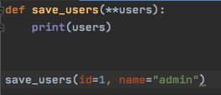
  + 
* So the next thing that we are going to be talking about is the difference between pie charts and the line graph. The first thing that we are going to be taking a look at is how the pie chart is structured as and then we are going to compare it with the structure of the line graph. We are then going to see how these graphs are similar and how these graphs are different.
  + 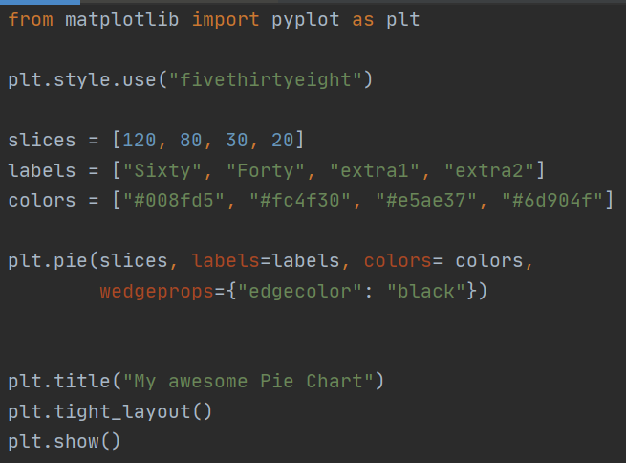
  + 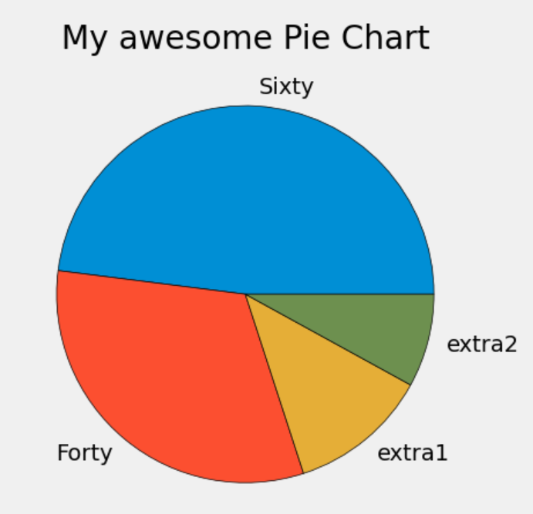
    - So this is the most basic pie chart one thing that I really want you to focus on is the slices. Check the slices. When we were doing the line graph what we could tell was that we had x data and then y data and thus planted the data on a graph. So startling we are labeling 3 variables: slices, labels, colors. Now what's interesting is that slices are basically taking data just like the line graph that we had. The concepts are very similar However the thing to know here is that the % are all within a list and they are not being compared to other numbers since it's not really a line graph. Something else that you need to know is that the variables that you are creating in the order that you put variables to list how they are going to be portrayed. For example slices - 120, labels - “Sixty”, colors - #008fd5 that's resulting in each section on the pie charts blue section. The other thing that was really new for me was that how “sixty” and “008fd5” I will elaborate a little more below
  + 
    - Now this is from the line graph as you can see the color and label is something are arguments within the method and they are both defined by strings and the color code and the label is defined as All Devs
  + 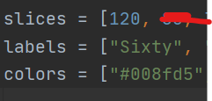
  + 
    - Now this is from the pie chart but the thing that i want you to take away from here is that pay attention to the arguments when it comes to this graph since your calling a section a name and assigning the section a color therefore your making a list and storing it in its place such as [0, 1, 2, 3, 4] etc and when doing this when you call the arguments labels and colors your are just storing the variables within the arguments.
* So in conclusion there are two ways of labeling arguments either through list or directly labeling it. The very next thing that we are going to be talking about is wedgeprops = {“edgecolor”: “black”} it basically takes keys such as edgecolor and linewidth. This is making the circle darker and more presentful. Now we are going to be doing the same graph but in a little bit more details.
  + 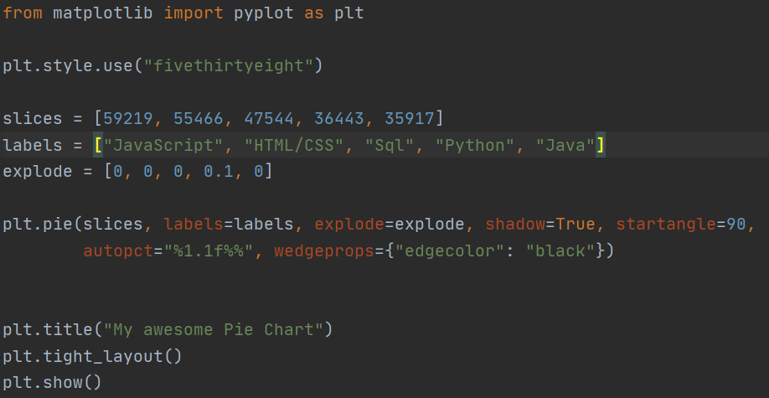
  + 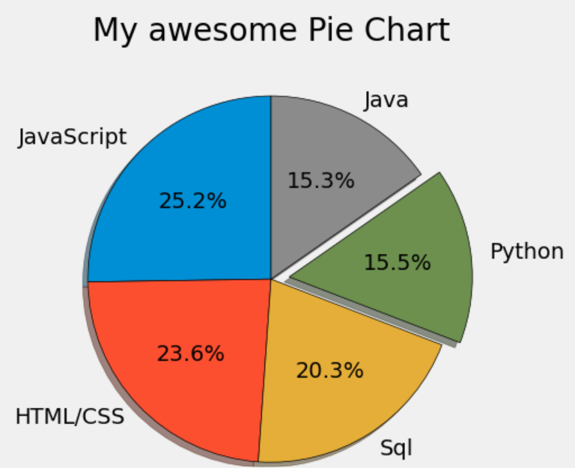
    - So as you can see in the code we begin with the same slices and labels and the we plot them but then we introduce a little bit more stuff to it later on
    - So first is the explode. What this is doing is its offsetting python by 0.1 from the center. The reason why this is useful is because when your doing a presentation and you want to highlight a certain point of view of the graph then you can do this.
    - shadow = True its basically casting a shadow in the background of the graph
    - startangle = 90 its starting the graph at 90 degrees
    - autopct = “%1.1f%%” enables you to display the percentage value were going to take a look at this later on dont focus to much on it atm
    - Lastly we ended with wedgeprop which gave the edge color.

* So the very next thing that we are going to be talking about is object oriented programming there are alot of thing that you want to focus on one of the thing being that down below.
  + 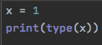
  + 

So when we say x = 1 were actually saying x is the object to the type integer with the value 1. **Objects** = is simply a collection of data variables and methods (functions) that act on the data. **An object is also called an instance of the class and creating an object is called instantiation**. Everything that we work within python is an object of some kind of class

* + 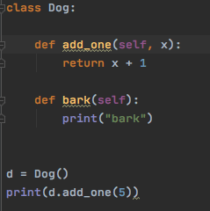
  + 
    - Something that i really wanted to point out in this code is look at the add_one i always wondered how come on different methods we have different parameters and what they actually mean is when you put in the parameter therefore you need to put in the specific value so that method can work
  + 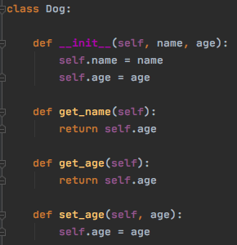
  + 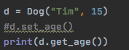
    - So now we are going to be examining this code in more details the thing to know here is spacing is important but first we define the __init__ and within it we have two parameter name and age from there we call another method called get_name and ( i should have typed return name) but its basically returning the name parameter. From there we have get_age and that is responsible for returning the age parameter/ lastly we have set_age and from there we put age parameter and then setting it as self.age = age now you might be wondering why? the reason being that age is being overridden here. This was kind of new for me because i was thinking to myself we already have age defined why do we need to define it again? but the reason being is that your overriding the value of age and thus resetting it. So the next example where going to be talking about in more details but the idea is that we are going to be creating a student class and course class and basically enrolling the students in the courses.
  + 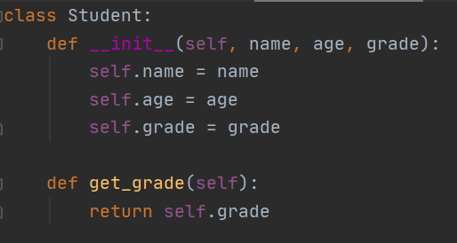
    - This is the Student class as you can see we have given the student class 3 parameters name, age, grade we are going to be filling them in later on Another thing to know is that initialization is really key here and whatever you initialize you fill.
    - Another thing to notice here is that we have another method and its called get_grade and the thing to take away here is that we are basically returning the grade here. Now you might be wondering what grade? so when you fill out the value in grade when you make an instance for the class that is the grade that you will be returning.
  + 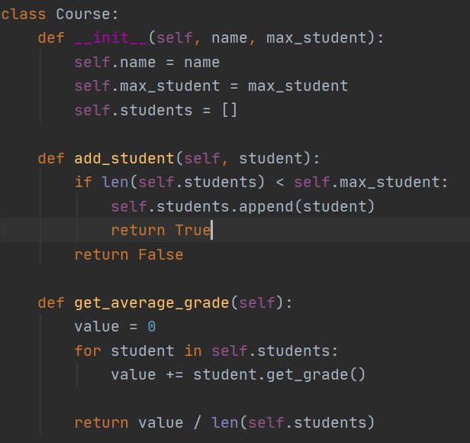
    - Now we have a Course class and within the course class we have 2 methods and one initialization. Before we start, whenever it comes to object oriented programming you have to relate what is going on in sense of seeing the bigger picture. So think that hey I just made a student class that is responsible for collecting the name, age and grade of any student now the next thing that i need is the course.
    - lets start off with the initialization, in here we have been given two parameters name and max_student. Something that I want you to take away from this is that before you begin the code and start rushing to dividing later on you have to initialize the class so when you make an instance you label the class name and its max students. what that means is that we will be giving the class a name and how many students the class can hold. Now the next thing that is on my mind is self.students = [ ] you might be wondering why is it that you have this whats the point of doing this? So this is really simple because its saying if the number of students is less than the max capacity then add the students to the room. Something that you need to think of is that there are two different values one is the max students that the course can hold and the other is the list of students that you can keep adding onto. The code is basically saying that return True if the condition is met or return false if condition hasn’t met. Another thing that i forgot to mention was the student within parameter its basically saying add the student if list is less then max student else return Fasle
    - Another thing that i want to mention in this code is that the max_student has a certain stop point and the students lists doesnt it basically keep going and going and your comparing both if list that keeps going is less than max students then add this student thats what that code is saying.
  + 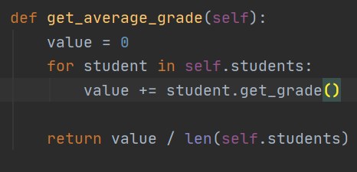
    - The last method is called get_average_grade and the thing to know here it is really simple what is going on just takes some time to understand so initially we have value set to 0 and then we introduce a for loop now this loop is responsible for each student in student**s** then its basically saying value = value + student.get_grade() and if you were to look at the get_grade( ) there is a method on it in student that is responsible for returning the grade only so that is why it know how to call the grade only. The next thing to know return is at end its average its basically saying whatever the value is divide it by how many students there are
    - so its gonna look like 0 + 95 +75 = 170 / 2 = 85
  + 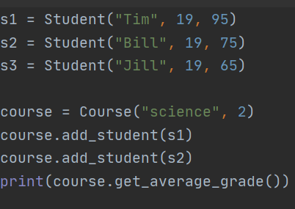
    - So now we are creating instance of a class with 3 students and then we are creating a science course which can hold 2 people in it. Notice how we are creating the instance we are saying instance = class(argument, argument, argument) and the second one same thing and we use instance.method(argument) and lastly its print(instance.method)
  + 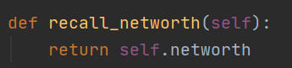
  + 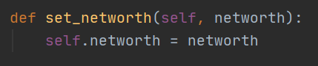
  + 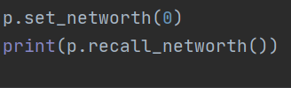
    - So take a look at this code the thing to take away here is that we are putting networth within the method and something else to know is that networth is being used elsewhere in the full code as well and whats happening is that you are over riding the value of networth and the thing to know here is that networth is being reestablished in the program and then we are made an object of the class called the method and then filled in the method with argument and printed recall networth.
  + 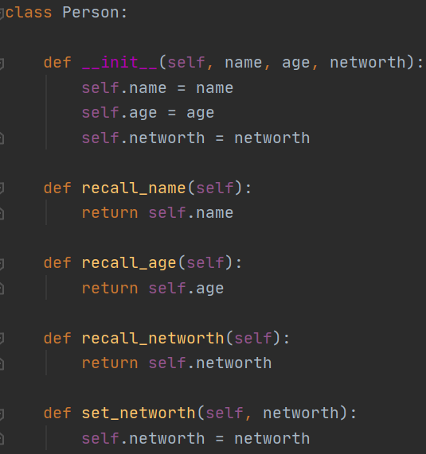
  + 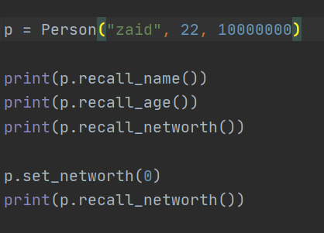
* Another cool thing to understand is that when it comes to object oriented programing the thing when it comes to the def method you can even put int and strings as well this is something that might be useful later on.
  + 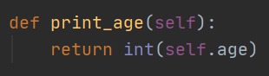
* Take a look at the next code and see what you see different from the other code that we did.
  + 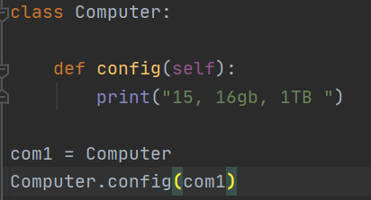
    - So as you can see the ideaology is the same working with classes but notice the difference comes when you are working with the instance. So its basically saying class.method(instance) and the way i was doing it was making an instance = class (fill in info) my theory from this is that since we are filling out the information therefore we are leading with instance if we werent filling out the information then and just print it out we could have done class.method.instance
    - Something else that is really important when it comes to SELF is you might be wondering hey why are we using self ? the thing to know is that the **config is going to take the argument of com1 and pass that to self**
    - **Encapsulation** - the best way to think about this is think in pharmacy what happens your basically putting more drug within the capsule and its basically saying instead of having variables after variables then it becomes hell to be honest. So another way of think object oriented programming is think of a desk filled with files all over the place and you are just sorting out the files.
    - **Abstraction** - think of it this way abstraction is basically lets say you run a program and it has plenty of methods and stuff and your hiding the methods from the viewer so it doesnt get complicated and users like what the heck am i looking at? and another thing to know here is that think of a DVD player outside everything is hidden and all your focused is on the remote.
    - **inheritance** - helps us from keep on rewriting the code so think of it this way imagine instead of writing an essay and that essay for a history class and another history class instead of writing the same essay all over the again what you can just do inheritance or “submit another paper in”
    - Another helpful tool is pressing and **holding control and clicking any method function** etc what happens is that your getting more information on it.
    - Another detail moment is that your not putting com1 = Computer**( )** the reason why you did not need to will make more sense in the next example. below
* So the best way to think of object oriented programming is think of a car the make, model, color are the properties and has methods like start( ) stop( ) and move( ). The thing to know here is when it comes to thinking of programming object oriented wise so think of elements that define a feature and then there are elements and then there are methods so think of methods that are getting stuff done. So think of it this way hot looks which defines features and intellect which gets things done. Another way to think of this is attributes and behavior the attributes are like how it looks and behavior is more so of of it acts.
  + 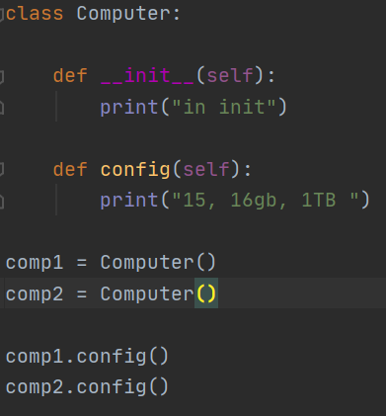
  + 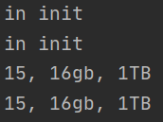
    - So take a look at this code now we are accessing the __init__ special method so now you might be wondering why is it that in init is being printed twice the reason why it is doing that is because you have two objects and since your putting two of them its going to be printed out two times. So another thing to know here is that Computer **( )** what this is doing is that its instatatiting and will call the object for you. Something that really makes alot of sense is that when you pass in parameters
  + 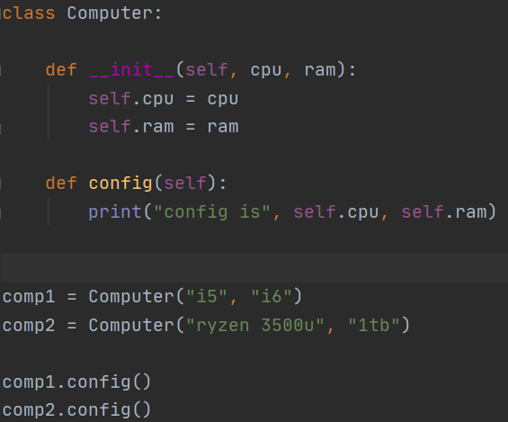
    - So when you take a look at this code theres two thing that you need to know when you see the first self in the init there are 3 parameters so in the self its going to be the comp1 and in the cpu its going to be 15 and in the ram its going to be i6 the so this gives a better understanding of the self is working so think of it this way its putting the instance of the class within the self. Which makes more sense since your putting in the instance and putting self then you can access the arguments to put within the parameters. Another thing to know in the second def is that you might be wondering why is it that we have self.cpu and self.ram and ive seen in other codes where they dont have self on some and have self on some the reasons why its like that is because when its a local variable then you dont need self but when its already attached to an instance then you need self.varibale this is really cool because i kept asking that question and now it makes more sense.
    - Heap memory this a memory where all the objects are stored something worth mentioning here is everytime you create a new object new memory is then allocated.
  + 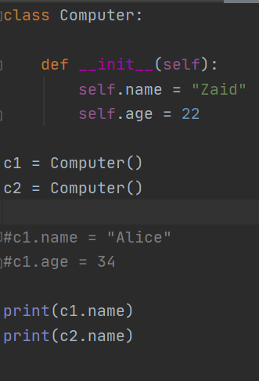
    - So this next code as you can see that we have commented some part of the code out but something that i want you to know is that within the def __init__ we hae named two variables name and age and set them to something now when we create two different objects but we call the same name we are getting the same results a way to override the name within the __init__ is similar to how you were to override a method you can just do call the object.name = new name see down below
  + 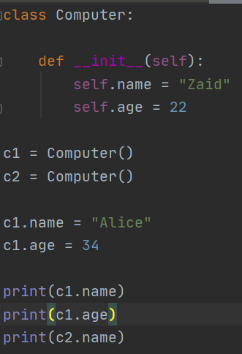
    - So take a look at this code your first name and age were defined and then your had overridden them within the init by creating instance and thus renaming the variable. So basically you created two objects named c1 and c2 and c1 is the object that hold new information for name and age while while c2 is still the same and when your printing out the properties of c1 and c2 they print out to what was changed in the init which is c1 and what wasnt which is c2. The bigger picture of this code is that your overriding the instatitation of the code.
* So the next thing that we are going to be talking about is when it comes to comparing two objects its actually really simple but there is a twist look at the code below to see what i am talking about.
  + 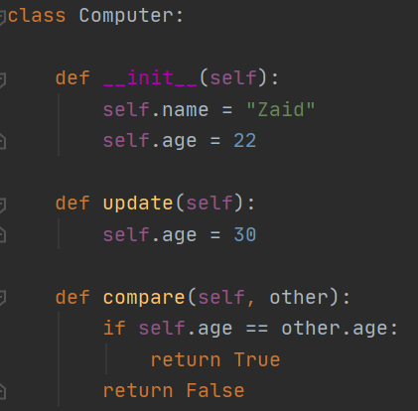
    - So notice how we passed the def compare there are some important thing to know here first is that we have two objects c1 and c2 and c1 is being passed into the self and c2 is being passed into the other and now we have an if statement that is basically saying if self.age == other.age this is saying if the object are matching. An important thing to take away from this is that when it comes to other you dont need to name it according to the object you can name it whatever you like the idea is placement within python thats all. The other thing to know is the structure of return false instead of writing else: return False you can just say return False.
  + 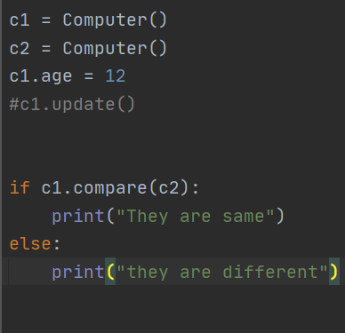
  + 
    - So take a look at this code the first question to my mind was hey why do we have an if and else statement when ti comes to outside the code its so weird cuz i thought outside the code we just call methods that do stuff for us rather then all this. but we have if and else statement and we have a method within the if and else statement that is comparing our two objects
    - The reason why they are printing out they are different is because we have c1.age = 12 therefore the ages are not the same.
* So the next thing that we are going to be talking about is class variables and instance variables class variables are outside the __initi__ and instance are inside the __init__ Take a look at the next code to see what i am talking about. **namespace** = is an area where you can create and store objects / value >> **class namespace** - where you store all the class and **object name space / instance** - where you store all the instances.
  + 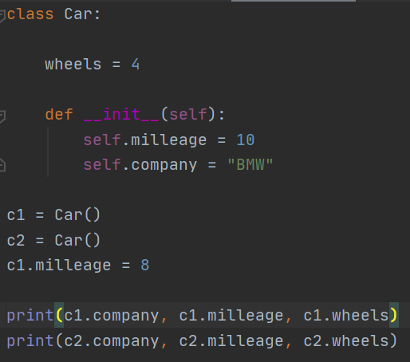
  + 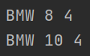
    - So as you can see the wheels is the class variables these are the variables that are not going to be affected by any changes however the milages and company is the instance variables these are going to be affected by change another thing i want you to focus is that look at how your printing everything out you simply put a common and print the next thing to line. and if you make a change to class variable then it effects all the objects
  + 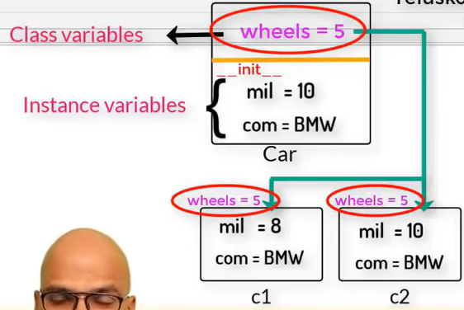
    - So take a look at the class variables named wheel and within it there are instance variables the init named mil and com as you can see when you pass a class variable its going into all the different objects that important to know whatever changes you make to class that goes into all the objects.
* Another thing that we are going to be talking about is the deiffence between setters and getter the thing to know here is that its really simple the best way to describe getters is that that they are retrieving and setters is that its basically setting below we have examples of the difference between setters and getters.
  + 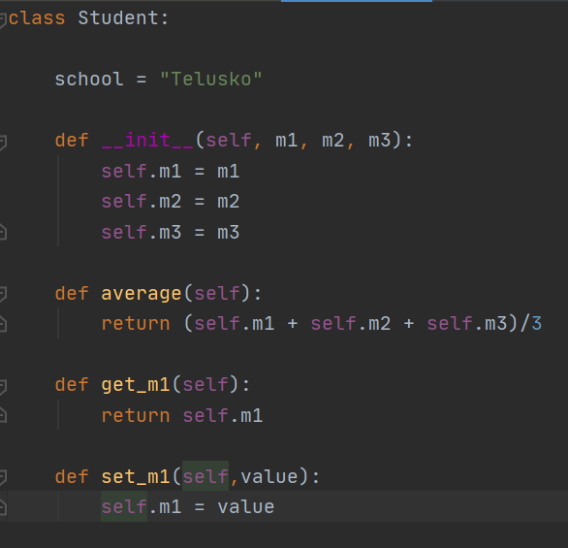
    - So take a look at this code the get_m1 is basically going to be returning whatever argument we pass in to m1 and set_m1 is going to set m1 the thing to know here is that when setting or retrieving a value what your going to be doing is that your making a function and within the functions they are doing their appropriate jobs. Another thing to know here is look at the set_m1 = value we have different name attached to parameter it doesnt have to be self.m1 = m1 it can be that self.m1 = value or self.m1 = car & etc.
    - **Another thing to realize here is that when you have been given 3 variables you would have to use 3 different methods either set or get.**
* So the next thing that we are talking about is a class methods and they are used for working with the class outside of the __init__ pay attention to the format of it.
  + 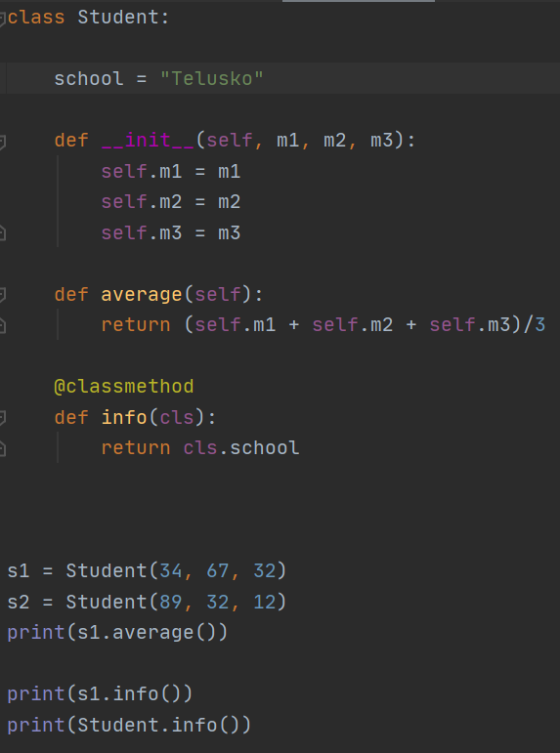
    - So take a look at this code right off the bat you can see the difference it the other codes your passing self which are linked to the initialization but when its not linked to class you are using **cls** another thing to know here is the @classmethod what this is doing its telling python that hey this is a class method and lastly pay attention to the print statement print(s1.info( )) and print**(**Student.info( )) what you can tell from here is that your basically calling the class and the name of that method for the class something else that you need to know is the Student.info is the better alternative when it comes to working with class.
* Something else that we are going to be talking about is static methods now these methods are the ones that i always question, such as hey how come in some we are using self and in other methods we are not using self ? what is the ruling behind that. Now these type of methods are called **Static method -** and they have nothing to do with class and instance. The thing to also know here is that think the self are the ones that take in arguments and run parameters and to understand class method you have to know is that they are the ones that work outside the initialization and are common in all objects. The code below is basically going to explain this more further.
  + 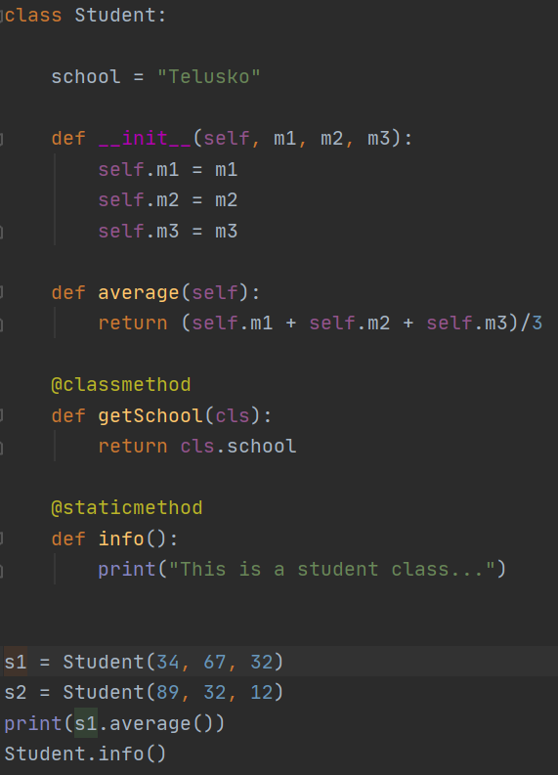
    - So notice we called another decorator named staticmethod but the important thing to know here is that we basically have a method that is not a class method nor an initialization method (self)
    - Another thing that i might have forgot to mention in this code is that static method is basically we dont have to establish any parameter within it.
  + 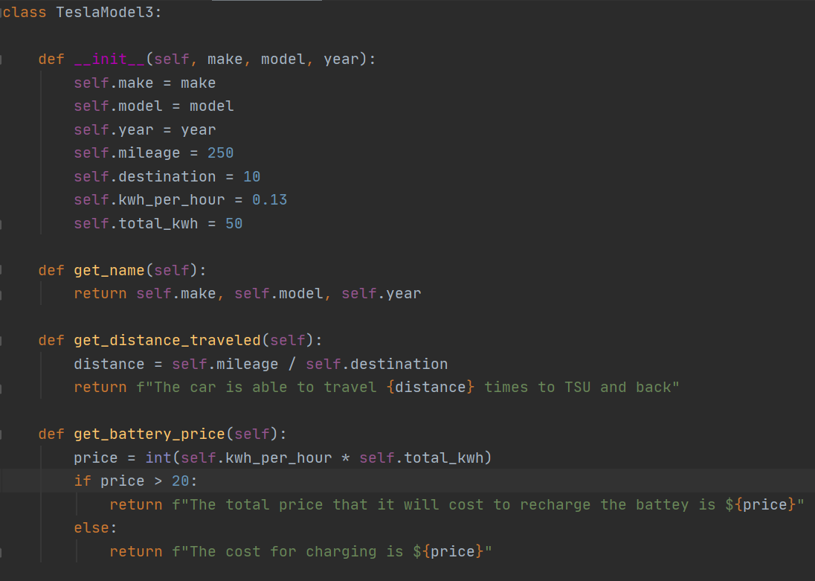
  + 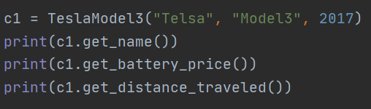
  + 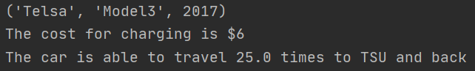
    - So this is actually a code that i had written by myself which is really cool but something i noticed right of the bat when it came to this code was that in my initialization i was labeling way to much and when i started labeling only a certain amount and the rest i had put within the bottom and attributed it with self then i basically used set and get methods which i made myself and did the appropriate setup. Also noticed the string formatting that i did in here.
* So the next code that we are going to be learning is going to be cool because in one of the pygame projects i saw this being used and i was like wait a minute what the heck is this? So be sure to see down below.
  + 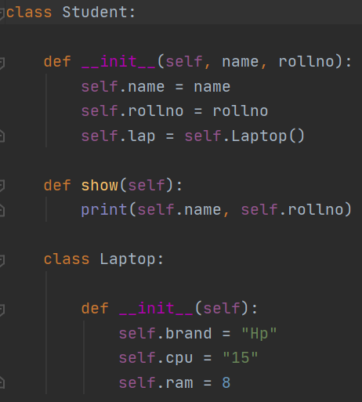
  + 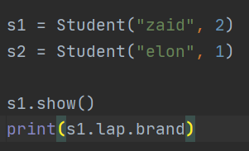
  + 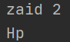
    - So take a look at this code and you can see that we have a class within a class the cool thing about this code is that where actually using initialization and within the initialization we have 3 terms brand, cpu, ram and the cool thing about this is that and also notice how we passed in self to each which its interconnecting and all. The thing to know however is that **self.lap = self.Laptop()**  the most important thing that you can take away from here is that your creating an object within the main class for the new class. So now the next thing that i want you to fix your attention to is the formatting **s1.lap.brand** now the thing that you are asking to yourself is that how come we are using this format? why is it that we are doing it this way? why cant we just call s1(name of object according to first init) . brand ( which is the init in another class) the reason why we cant do this is because remember the brand is part of another class called laptop so that is why we did it this way where we made an object in parent class and called it from that object. Another thing to understand is when your making an object to class your also adding the self to both the object and class that way they become connected and then you can use lap obj that you created as a mediator. Another thing that i wanted to mention the reason why they do s1.lap.brand is think of it as a google maps to get to your destination you can have to follow the route and at each stop and this is all used to get the init values of the second class.
  + 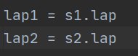
    - Right off the bat you can see that you are making an object one question that i have in my mind is that why are we making these object when they aren't really printing out anything? but standing from the fact alone we know that we are making two objects and notice the other one we were printing out “brand” because of brand. So we are going to be looking at the bigger picture in the next code so pay close attention.
    - Another thing that i wanted to mention here after looking at this the second day i relaized that when you made an object from the class that is in a class and when you call lap1 = s1.lap so the lap1 thus becomes the new object and s1 is the student that you created with the first init method the values you filled out and lap becomes the laptop class but the idea is that you can make objects from objects of class this is what its trying to teach that your not fixed with just one object and class.
  + 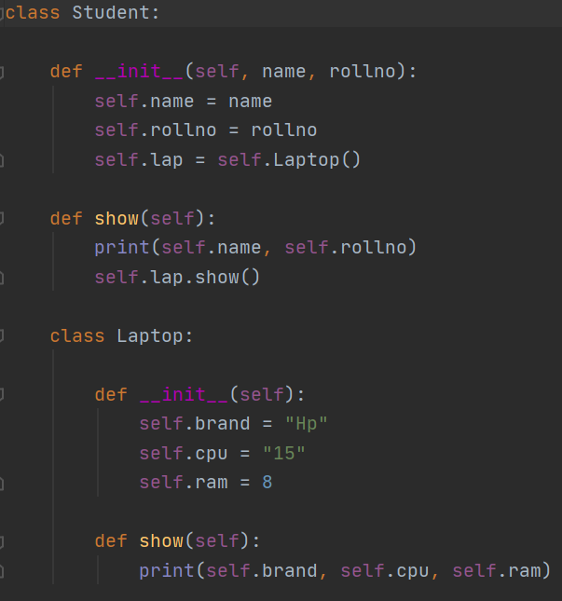
    - A lot of this code is similar to the code above but there are some key differences the very first thing is that the show methods pay attention how there are two show methods and understand one thing that each show method will be different it wont be the same show method. Another thing that i want you to understand is self.lap.show( ) So now we have to understand the bigger picture here. So now comes the bigger question why do we need self.lap.show( ) ? so understand that self.lap is basically used for the object to pair to Laptop class and from that class you are accessing the method and thats called show Now comes the bigger question in the next picture
  + 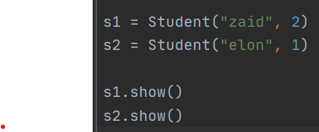
    - The question that had come to my mind was how come s1.show( ) and s2.show( ) how do they know which show( ) to go to?
    - So here is what i think is happening here and i could be wrong on whats going on but i think when you say s1.show( ) your actually calling the method that is in the main class and to access the methods that are in the class within the class you have to put the **self.lap.show( )** the reason why you are doing this is because your calling the show method in laptop class, so its kind of like one method is doing the work of two methods in this case. So think of it an onion it has layers thats what the code is in a way where in order to get to the inside then you would have to call the class but before you can call the class you need to create an object for it.
  + 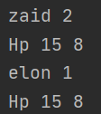
    - here is what the code is printing.
* So before we move on to the next stuff i really want you to pay attention to something so simple but you messed up in, we are going to be focusing on the return keyword the return keyword is responsible for a lot of things but dont confuse it with the print keyword i made the mistake of thinking that the return keywords is the same as the print keyword.
  + 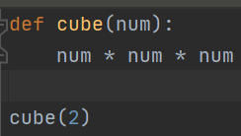
  + 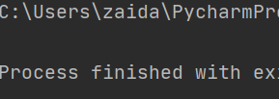
    - as you can see this code is printing nothing and your wondering wait a minute why is this code not printing out anything at all? the reason why this code is not printing anything out is because the calculation is happening in the background but technically thats all you specified.
  + 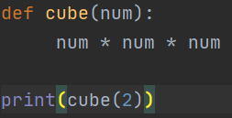
    - In the first code you could have made the argument that hey the reason why its not working is because you don’t have the print key well now we do have the print key and when we print this its giving us the value none
  + 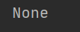
  + 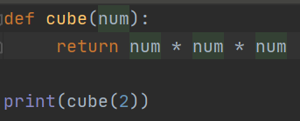
  + 
    - So take a look at this code since you put in return what your doing is that your actually now telling python that hey since i defined my function and i want to you to return the value. This is DIFFERENT from the print statement. Some thing else anything you **put after return** is **not going to get printed** out the cycle breaks **remember that!!**
  + 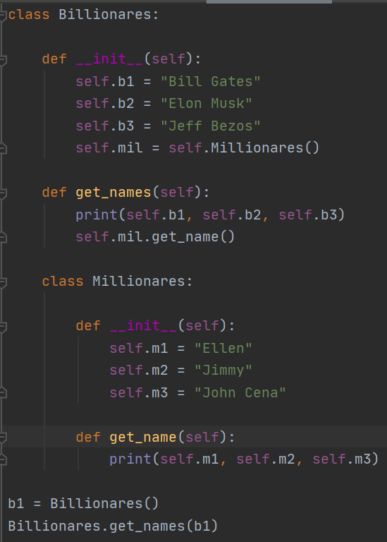
  + 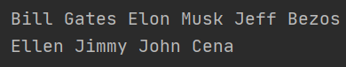
    - So this code is just like any other code tbh the only thing that i want you to understand in this code is that when we made an object b1 we then put b1 in billionaires.get_names because when we didnt turned out that we kept getting error saying missing self My theory is pretty simple when you start off with the __init__ and dont label anything when it comes to input then what happens is that you need to reference object within the class.method.object so that occupies the self.
* So now that we have that covered we are going to be moving on to the next thing it basically talks is **inheritance** now you might be thinking wait a minute isn't inheritance the same the the thing that we did well not necessarily because when we inherit what we are doing is that we are basically getting al the information from parent class and passing it down to child class.
  + 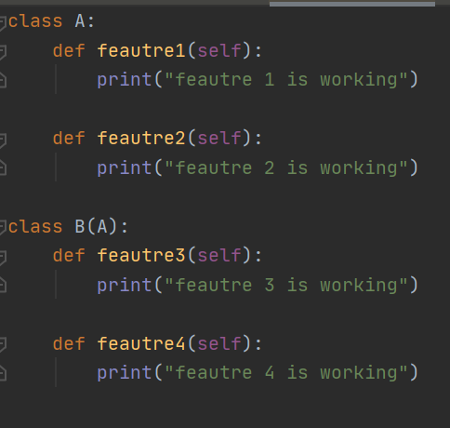
    - So take a look at this its really simple we have a second class named B and we then give our constructor ( ) and put in A what this does is that B can now access all the qualities of A
  + 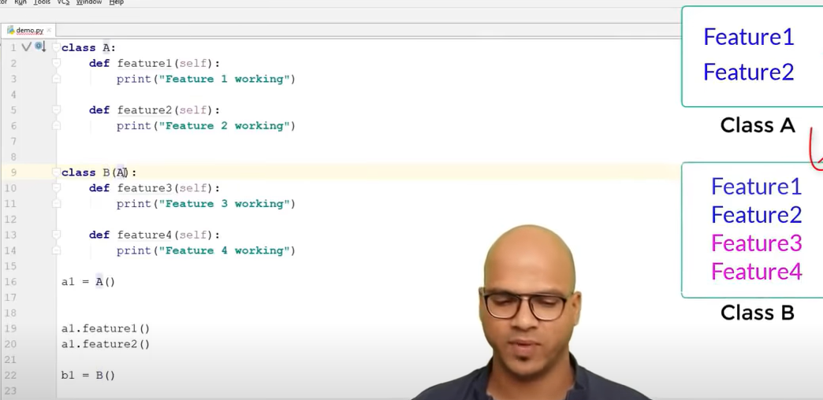
    - Take a look at chart on the right it shows very visually what happening her class B is inheriting the features of class A. Something that i think its pretty cool is that lets say if we made another class called C and inherit from class B what features will it inherit?
  + 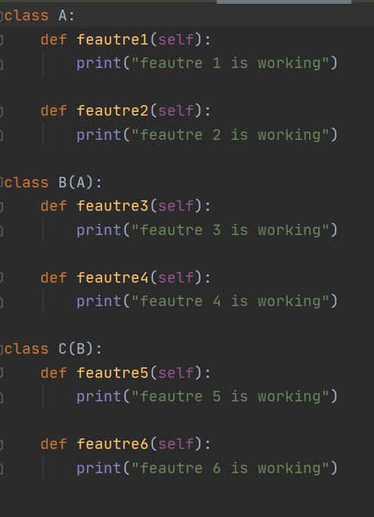
    - So take a look at this code in the first line we have the parent class in the second line we have the child class and the last line we have the baby class but the thing i want you to take away from this is the idea that the second class is inheritng from the first and the third is inherting from the second and first I hoenstly didint think of this at all because i was thinking oh maybe it might be inheriting just from B but since b is getting A therefore its inheriting from A as well.
  + 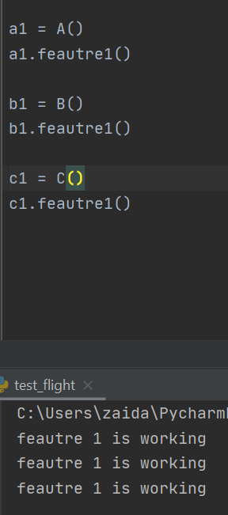
    - see this proves it class C is printing the stuff within A and it shows how its inheriting from B which in thus is inheriting from A.
  + 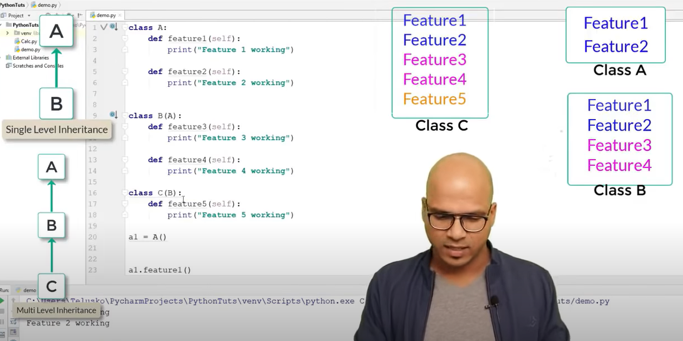
  + 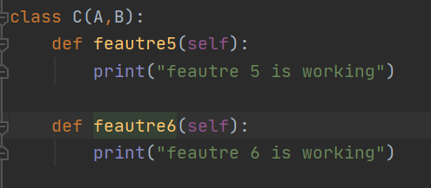
    - **SOMETHING IMPORTANT HERE!!!** The thing to take away from all this is take a look at class C right here your basically importing A, B but the thing that i want you to take away from this is that look at the format you can add more classes rather then just this. But the basic thing to understand here is that whatever you import is whatever you use and then you also have to understand that the stuff that you import is it already importing stuff as well or nah?
* Something that we need to also know is that how will the __init__ method work lets say we we call class B and class A has an init method will B also refer to A init method or no and why is this important?
  + 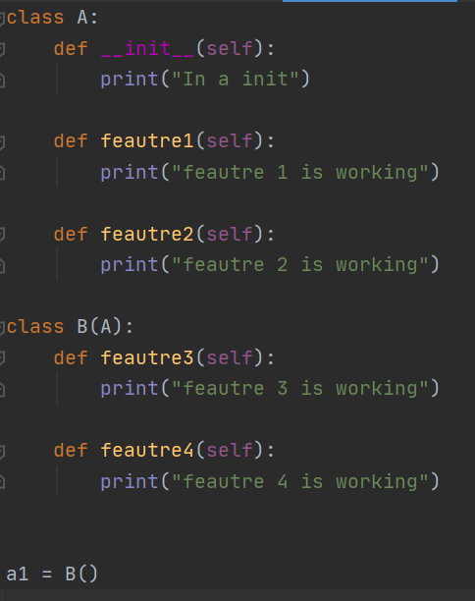
    - So take a look at this code as you can see we have created an object of B and thus doing so will it call the __init__ of class A
  + 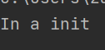
    - It does so what does it mean it means that you can access all the self attributes that are in the init class or the initialization attributes not just the methods only. Now heres a question what about having your own __init__ method in class B what will happen?
  + 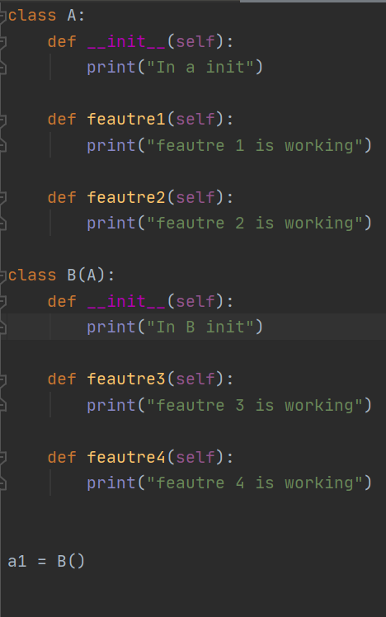
  + 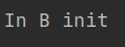
    - So take a look at what is happening here as you can see that both class A and class B has init methods and once thing to remember is init if not stated is look at from up meaning if not specified init in b then it goes to A see if there is an init there and since we already have one in b therefore python doesn't go to A init it just stays at B. That is important to remember because i was thinking oh its going to call both init rather not it called the one in its class and if not there the one above it. Now here is a question lets say if you need the init class of A then what are you going to do?
  + 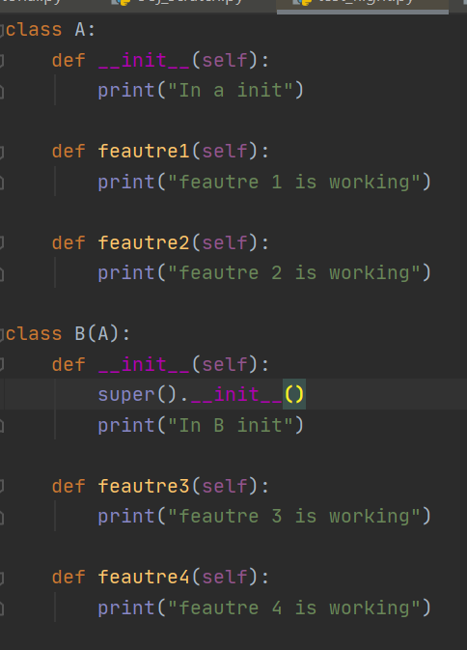
    - Now comes the keyword **super** to the rescue so when i first started learning python i learned that super is responsible for accessing the init from another class but i never really understood it. But what its saying is that hey since you need to get access to the init of A initializations then here use me i can get you there and something else to know here is that when using super is pay attention to format its super( ).__init__ so ultimately super () . method name. Another thing that i forgot to add was that notice how the A class is being printed first and then B class
  + 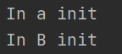
* So the next thing that we are going to be talking about which is kind of confusing is what happens lets say we have super at C and we call init and we are calling both A and B and they both have init then what should we do?
  + 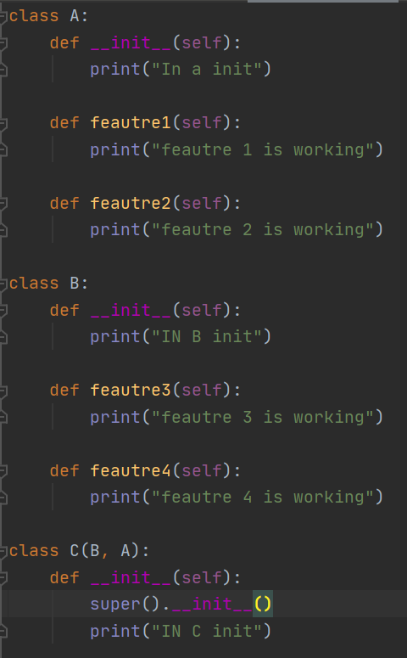
  + 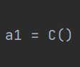
    - So take a look at this code and its really surprising because now since we have classes put within out class C you might be wondering wait a minute which __init__ is python referring to? it doesnt make any sense how does python know which __init__ to go to? well the thing to understand is pay attention to C(B, A) so this is important when you call super(). __init__ immediately python is going to the class in the left in this case B lets say if it was C(A,B) then python will refer to A __init__ class python favors the **left** the same goes for methods. Another thing that i forgot to metion was that **it will also execute itself so it will print out its own __init__ then the one to left -- > IMPORTANT!!** now we are going to see how it works in methods
  + 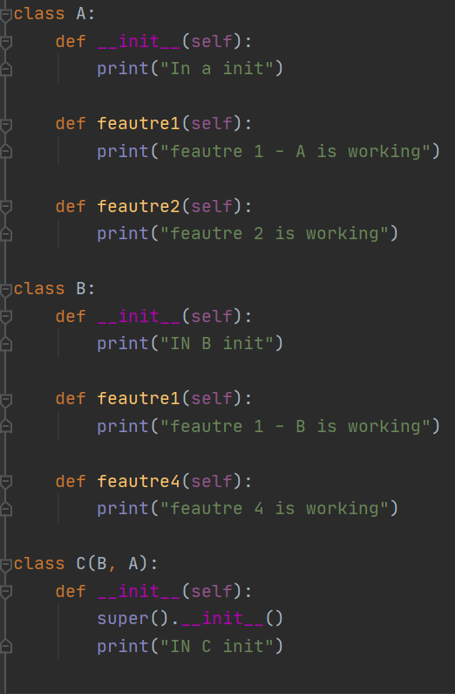
  + 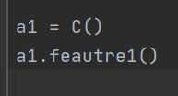
    - So take a look at this code what you can see here is that in class A and B we have a feature1 labeled and we are trying to run feature1 using the C class now you might be wondering hey since C class is using both A and B therefore which one is it going to print well the thing to know here is that its alot similar to the super class thing that we looked at python is going to refer to the class that is on the left regardless of the super or method. But one thing to know here is that it is going to be running itself first and then to the one in left. Another thing to know is you can use super class to acces other methods that are outside think of the super as a gateway.
  + 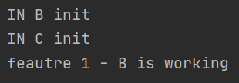
  + 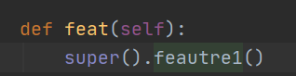
* Now comes the concept of duck typing the thing to remember when looking at duck typing is that there is this saying if it look like a duck quacks like a duck and behaves like a duck then it is a duck. I really dont know why we have but look at this code and see what i am talking about
  + 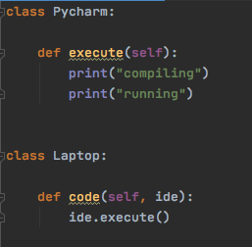
    - so looking at this code we can see that we have two different classes one class name is Pycharm and the other class name is Laptop within these two classes we have two different methods execute and code the thing to know is that we are going to be calling this code. In other words we are going to be creating objects and this other important point to remember is that when creating the object we cant just say lap = Laptop() and then object.method() because we are trying to pair the parameter “ide” to the class Pycharm with a variable named x and thus doing so when we call lap1.code(x) we are actually calling the laptop class and running code method and that is going to do the ide.execute and in this case x and ide are same thing and their job is to link to pycharm class (and reason why its same thing is cuz of self x os object goes into ide and ide.execute) so its actually saying Pycharm.execute() which lo and behold that is is another class and method and it prints compiling and running
  + 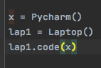
    - The bigger picture here to understand is you can execute other methods in other classes using the parameter and another detail moment is that when you have ide.exectue your basically telling python hey i need you to execute this METHOD which is in another Class therefore you have to make x a variable which is linked to Class that acts as the gateway so you can access the methods.
  + 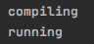
    - This is what the code is going to be printing out
  + 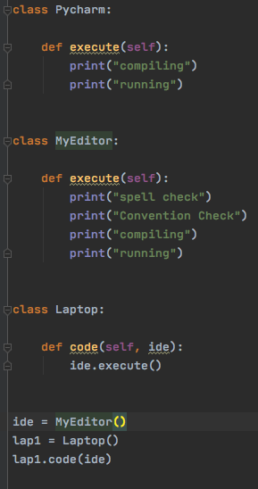
    - So take a look at this code now you might be wondering what is so important in this code what makes this special but the main concept to understand is that you have three different classes and in Pycharm and Myeditor class you have two execute methods on top of that the last class you basically have this ide parameter passes and in that you can either set to pycharm or myeditor as long as you have the execute method then it will run that is known as duck typing. One really **IMPORTANT** thing to remember is that when you pass in ide you cant just use it you have to fill it out first. I feel like your going to forget about that!! so remember that
  + 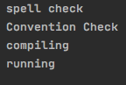
    - So as you can see now that we are calling the MyEditor class therefore you are getting the print messages in its class.
* So the next thing we are going to be talking about which is pretty cool in my opinion its these methods that you can use and the cool thing about these methods are that it feels like im starting to go into more deeper waters.
  + 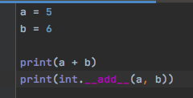
    - So take a look at this code as you can see it has two variables in which you are printing a + b and then in the second line you are printing (int.addmethod(a, b)) the reason why this is important is because it saves you lines of codes so you dont have to keep adding its a shorter way to work.
* So the next thing that we are going to be talking about is called operator overload the thing to know about operator overload is that lets say if you want to add two object values together you cant simply just add them all of you need to create an add method what thats going to do is that its going to be doing the adding for you. Because python doesnt know what add is when it comes to adding two different objects.
  + 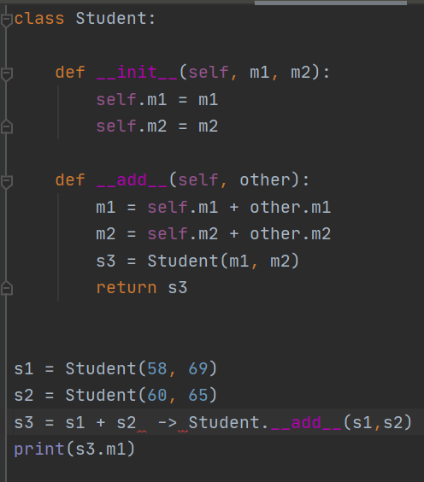
  + 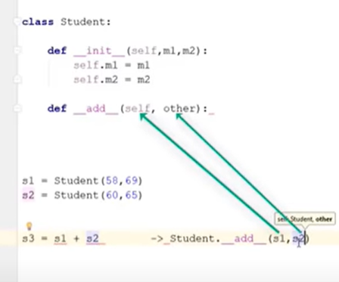
  + 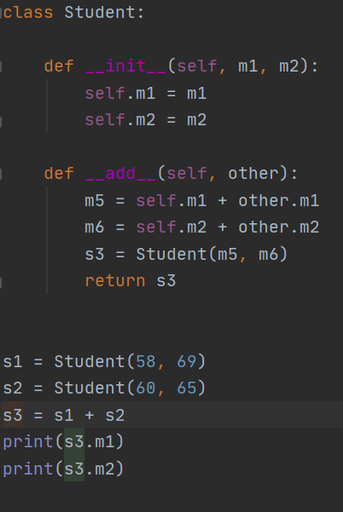
    - Something right off the bat that i want you to know is the **IGNORE** the arrow thing its basically used for better understanding. Now the best way to think about this is in rows not column i was thinking all wrong i thought that maybe your adding the numbers next to each other and here what your actually doing is that your adding the numbers in rows so top + bottom in this particular case. Something that i also wanted to mention was that this doesnt mean your only adding top and bottom number you can add the number on the 58 + 69 or 58 + 65 or 58 + 60. Another thing that you need to know in this code is that making another __add__ method is not going to solve your problem when it comes to add the second colum your in made method is solving it you just need to call it.
    - So lets start this code in the beginning the first thing that we are doing is that we are making a class in the class we have __init__ method from the __init__ method we are taking two variables called m1 and m2. Now the next thing that we need to know is the add method from here you can see that right off the bat we have **self, other** this is really important because in order to get here first you must create an object called which is paring the two objects together in this case s3 (object) = s1 ( student object1) + s2 (student object 2) another thing to know is that s1 goes into self and s2 goes into other Now the thing to understand is that m1 in this case is 58 and 60 and m2 is 69 and 65 think of it them as columns going down with each with its own category.
    - Now comes an important we are making an object and pairing it to the student class now you might be wondering why are we doing this ? what is the importance of it? **s3 = Student(m5, m6)** the reason why this is important is because your making an object of the student class and by doing so you are then passing in the parameters m5 and m6 and know that m5 is basically the two m1 that user entered and m6 is the two m2 that the user entered and yes they can be interchangeable. Now the most important thing to know is when you have the new totals plugged into the new variables those variables are in thus going back to m1 and m2 and then when you call the object s3 = Student(m5, m6) something that i should have cleared out was that s3 is an object it can also be s4 below i will attach a picture that make it more sense (check down below) So the important thing to know is when you are creating an object and it is linked to Student class and then its going to m1 and m2 and you are then recalling the m1 and m2.
  + 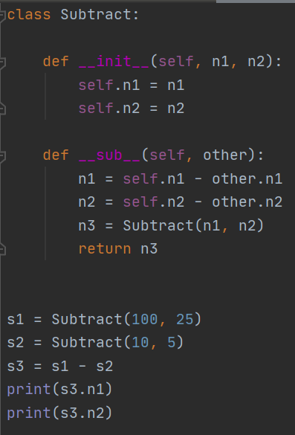
    - So take a look at this code as you can see here we have written a subtract method and in the subtract method and the thing that i want to expand my focus on is s3 = s1 - s2 and s1 is going to self and s2 is going to other. The other thing to know is that s3 is the OBJECT to the s1 (object with init) subtract s2 (object with init) and then s1 passes into self and s2 passes into other then you define a new value of n1 because you have two different objects and you need to do some math therefore you can redefine n1 to be **self.n1 - other. n1** and this is where the object comes in handy s3 = s1 - s2. So in short terms the reason why is first you need to do place the two different objects and subtract them using an object. Then you have to redfine the variables so they can subtract so in this case the self - other or n1 in s1 and n1 in s2. Lastly your making an object of the class because by doing so your calling the init and your basically pasting your new n1 and n2 there. Something else that i want to put focus on is the return a3 the reason why this is important is because when you state something such as create an object and thus you want a return value because the init is going to be executed and then its going to sub because they are special methods and once its done executing it needs to return a value
  + 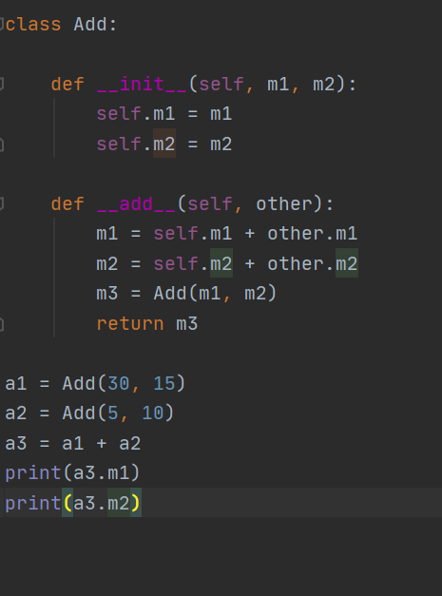
    - So dont worry to much about this just know that you when you create different object variables you can even repeat some.
* So we are going to be looking at something else in more details and it called gt greater than overall the concepts are really similar
  + 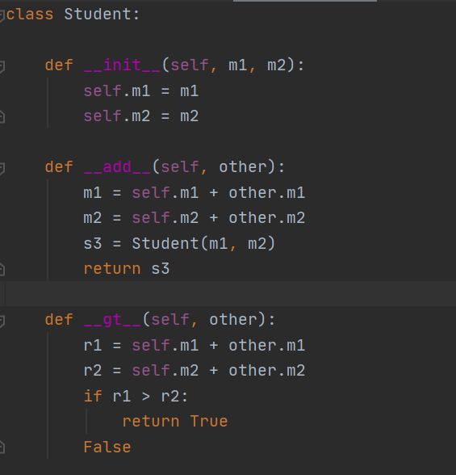
  + 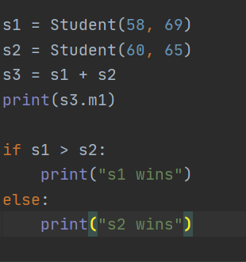
    - So take a look at this the thing to know here is that s1 has been established and s2 as well then just use a simple if and else condition that is responsible for doing the arithmetics.
* So we are going to be looking at this concept called arguments and keyword arguments this is an important concept and it will be best if you understand it because when using other methods when you press cntrl and click you will see it saying kwarguments and arguments.
  + 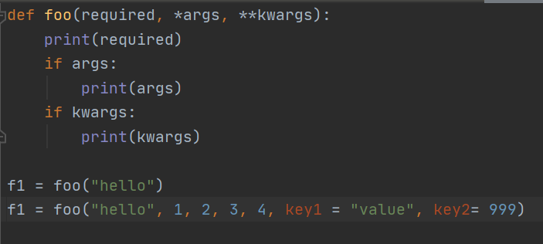
    - So take a look at this code as you can see this is an intro to arguments and keyword arguments so we have defined a method called foo and within the method we have put 3 parameters in required, * arg and **kwargs and we are simplie printing them but the thing to pay attention in this code is that in the first we have this sting called “hello” , and in arg we arguments 1, 2, 3, 4 and within keyword arguments we have keywords.
  + 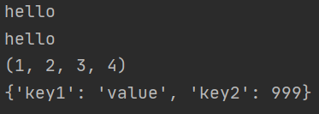
    - something else to know is that arg is actually a tuple and it cant be changed once tuple is set.
* So take a look at the next code and you can see that we are doing things in more details that will make more sense
  + 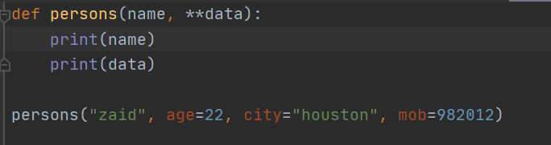
    - Now something that i wanted to mention when it says **data that means that its keyword arguments and you have to specify keywords
  + 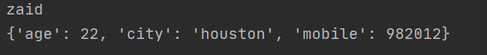
    - as you can see when you do it this way whats happening here is taht your speciifying keywords and because of **\*\*keywords** whats happening is that whatever is in the persons( ) goes into a dictionary. Now lets say if we only had *args what do you think that will do?
  + 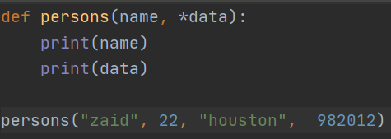
    - Take a look at this code this is the same code that we have the only one difference **\*data** what this is doing is that its basically getting the 22, “houston”, 982012 and is going to put it into a tuple
  + 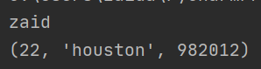
    - So this code as you can see since you defined only data its a tuple and therefore its putting everything in a tuple the other thing to know here is tuples are immutable.
* The next thing that we are going to be looking at is kwarg and the cool thing is where going to be recalling something that we learned in the past
  + 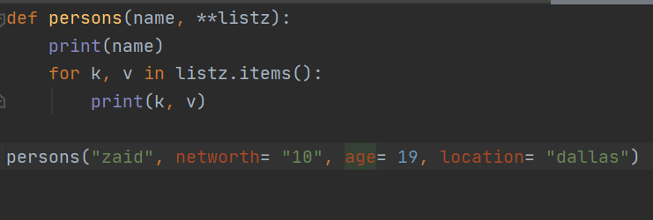
  + 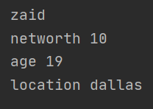
    - This is something that you learned in the past being applied here all the keywords are being stored within the listz. zaid is going to name and rest are going to **
* The next thing that we are going to be talking about is really simple but i think i fail to understand the concept take a look at this code down below and analyze what makes this code really special. The thing that we are going to be looking at more deeper is variables outside of the init method and try to look at the bigger picture of why they are important and what is the purpose to them.

* + 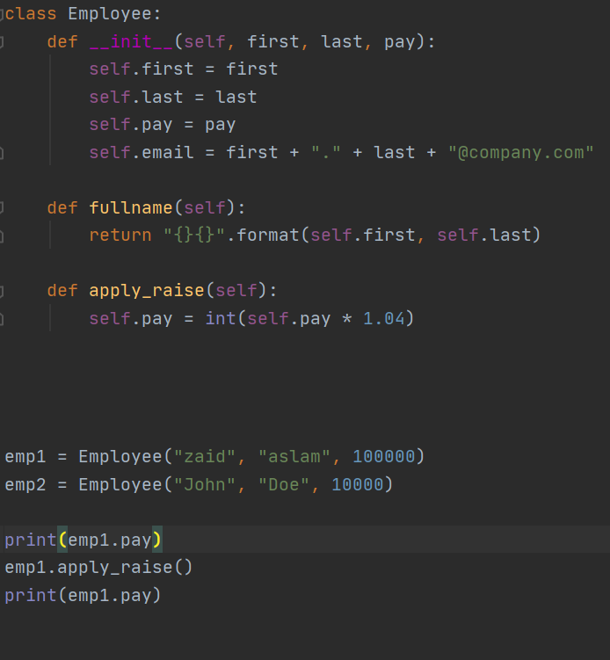
  + 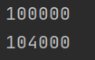
    - So this code is really simple but the thing that i want you take away from this code is the idea that your applying the **method to the object** now this understanding is really simple however this is a mistake that you made look down below. The bigger picture here is that first your calling the init variables and then applying method to object
  + 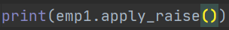
    - This code is wrong and you shouldn’t be using this because this is going to be printing out NONE the bigger picture to understand here is that your basically really simple first you must apply the method to the object and then print out the result not try to do it all at once.
* Something new that i learned was this thing called __dict__ and what it does it basically prints out everything that is in the dictionary.
  + 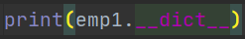
  + 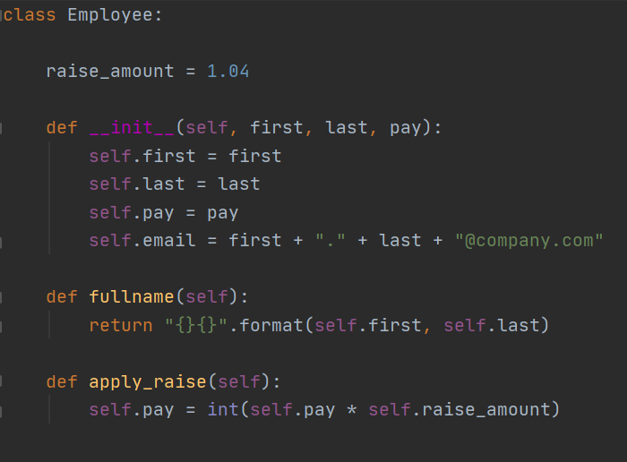
  + 
    - This is printing out the dictionary value that is stored because of the __init__ method and you might be wondering what about the objects ? just refer to the code of objects above they are same thing.
  + 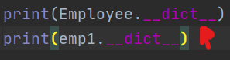
  + 
    - So take a look at these two codes above now you might be wondering wait a minute why is it important? what the reason behind this code why are they doing Employee.__dict__ and emp1.__dict__ what the difference here well first thing that we have to know is that Employee is the class and emp1 is the object and as you can see we highlighted this part called raise_amount = 1.04 the other code isnt important but the thing to take away here is that in the code above we can see that raise_amount is appearing in the **class but not the object**  the reason why this is important is look at the list above it has all the object parameters and arguments to fill the list but it doesnt have raise_amount however the Employee class has raise amount. Something else that i wanted to cover was that in the other video we learned that whenever you make a change to class it affects every object.
  + 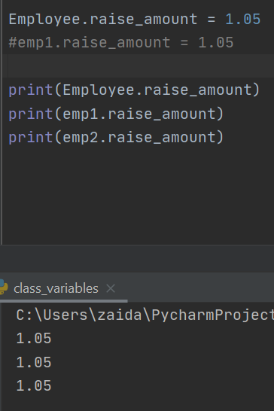
    - This part I want you to focus on is Employee.raise_amount = 1.05 as you can see in all the object its 1.05 this is something that we already learned in the previous video but what if we can change one method instead of all the methods.
  + 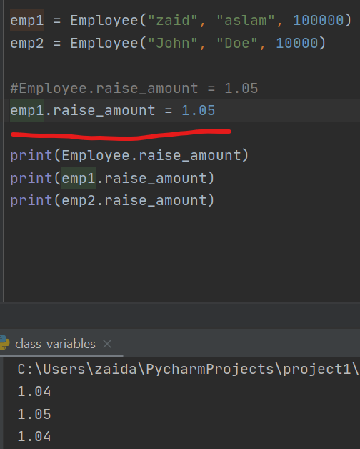
    - Take a look at this code as you can see that we are change one of the objects and not all of the objects i really thought this was cool because i didnt really think of that now lets say if you need to pass a raise to one object and other objects you dont want to you can just call object and thus pass raise rather then messing around with the whole thing. So the cool thing that i was thinking was that you can have a class variable that can be constant and then tweek it up when it comes to different objects and i was thinking i can use this in my car programming thing having a class variable that can do all the handy work and if i need to tweek something i can just specify for this object i want this amount not the class amount. Another thing that i learned was look down below. Something else that i forgot to mention the reason why this is possible is because of the **self.raise_amount & Employee.raise_amount** THE BIGGER PICTURE HERE ISjudging by what you use you can either mess with the class in total or just an object.
  + 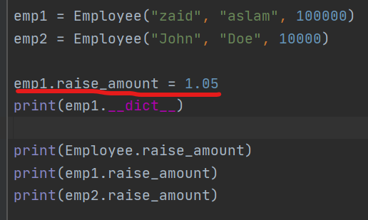
  + 
    - When doing it this way what you can see is that you raise_amount is being stored into the init method dictionary. I didnt know that its really cool learning this.
  + 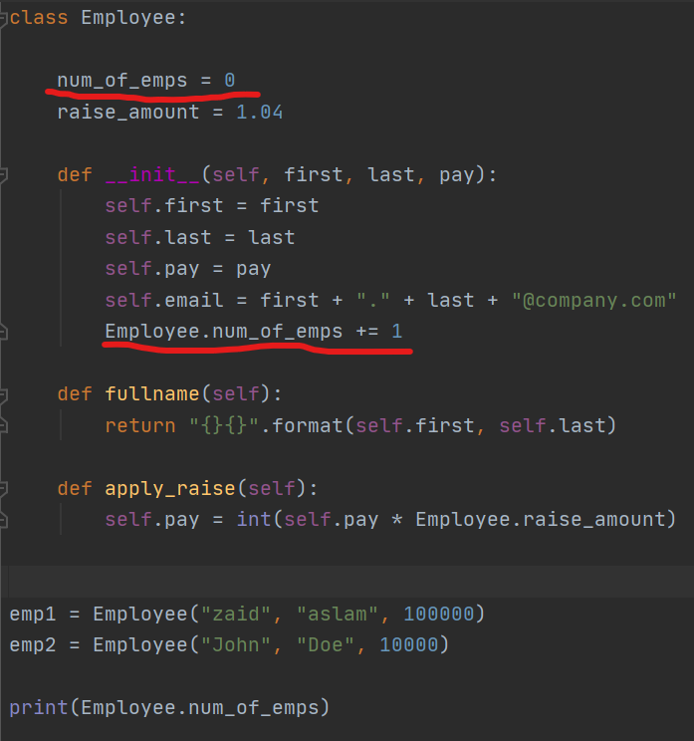
  + 
    - The cool thing about this code is that you have an outside variable called **num_of_emps = 0** then your doing **Employee.num_of_emps += 1**  the reason why its **Employee** its because its a class method if you did self.num_of_emps then it will refer to the object but when your using **Employee** its because then it refers to class and not object
* Something that we are going to be covering in more details is called class and static method and when to use them. So take a look down below you can see how they work
  + 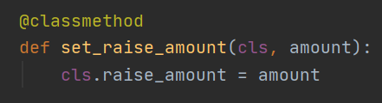
  + 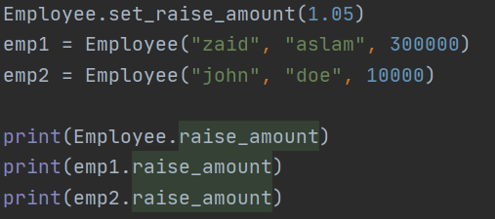
  + 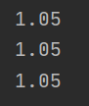
    - Something that i want you to notice right off the bat is that we have a decorator thats called class method saying this is a method that if you do something to then it will happen to the whole class. Notice how we are passing in two arguments the first is the cls this acts like self but cls itself is for class. the second argument we are passing in is called amount. Then we are calling raise_amount and attributing to the class method the next thing that i want you to focus in is that **Employee.set_raise_amount(1.05)** the cool thing here is that first we are calling the class and the method in this case the class method and then we are putting in 1.05 notice one thing the reason why we are putting in something in here is because we have (cls, **amount**) therefore we have to specify it.
* So the next thing that we are going to be talking about is a new concept that i actually never heard of but lets say when your writing a file and in the file there is **-** between the arguments so you cant really collect the data what you can do is write a class method and that is able to remove the - from the code. The advantage of doing this is when you do then whats happening is that your basically saving your self the trouble of having to manually do all that An important thing to know here is that this is a good way to know how to use class method and a real life scenario.
  + 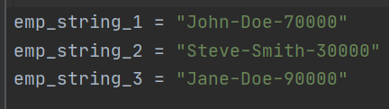
  + 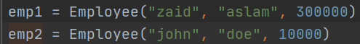
    - Take a look at this code as you can see the first , last , salary all have a - between them now you can go the route and do it manually but by doing so whats happening is that lets say you had to do this for 1000 people it will take forever. So dont work hard work smart. So now what we are going to be doing is that we are going to be writing a class method and that will be able to parse the whole file out properly.
  + 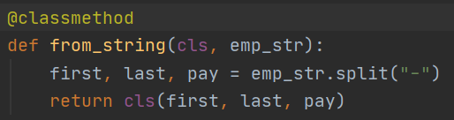
    - So take a look at this code we have a class method defined called from_string and within the code we pass the cls which is responsible whenever you state a class method and the next thing that we are passing is called emp_str this is responsible for taking in an argument (in this case will be our objects). So now pay attention to the format i think this is pretty cool because we have first, last, pay = emp_string which is taking in the argument which is the object and removing the - from the string. Then you will basically return the first, last, pay
  + 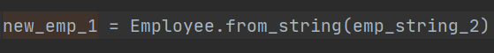
    - So take a look at this code as you can see you created an object called new_emp_1 = Class.method(object-string-that-needs-to-be-parsed) So this is actually really cool but the thing that we need to look at is that the object emp_string_2 is actually passing to emp_str and within it its running split function. So my theory is that when we are mentioning split whats happening is that were actually splitting the word wherever the “-” is so basically split when you see this - and thats whats happening here. Another thing that you want to understand is that the first, last, pay so my theory here is that you have to state what type of variables they are then you have to specify what you want to do with them after the = sign so its kind of like your breaking them up and then sorting them. Another thing that you need to know is that when returning you have to pass cls you can also use Employee its the same thing
* The next thing that we are going to be talking about is called static method now we know that static method are neither class method or methods that require self the thing however that we need to know is when to use them. So the next code that we are going to write is going to tell what the wether the day that you choose is going to fall on friday and saturday. Now something to know here is that monday = 1, tuesday = 2, wednesday = 3, thursday = 4, friday = 5, saturday = 6, sunday = 7
  + 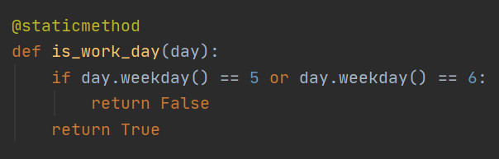
  + 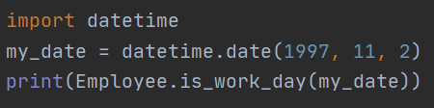
    - So take a look at this code we have a staticmethod called is_work_day now honestly this method is really simple because we have only one if statement and the if statement is basically saying if the day lands on friday or saturday return False else return True.
    - The next thing is that we are creating an object called my_data = datetime.date(year, month, day) now datetime.date is inbuilt im not to sure whats going on but the print statement is basically calling the class.staticmethod(object-specified) then object-specified passes into day and runs through the conditions.
* The next thing that we are going to talk about is inheritance in more details so be sure to pay attention. So there is this method called help and this is method is really cool because when this tells you what is going on so take a look at this code down below.
  + 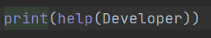
  + 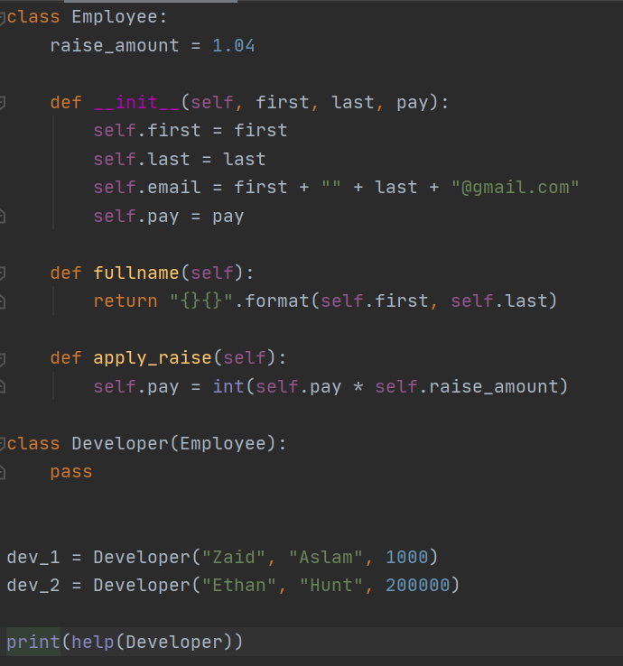
  + 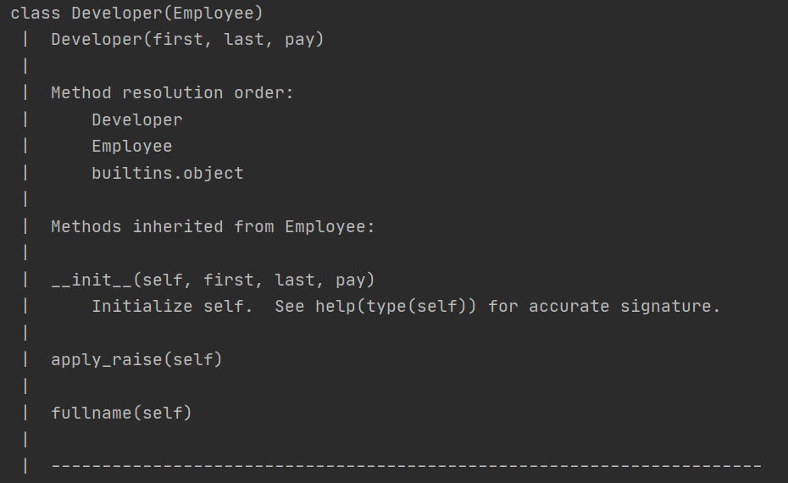
  + 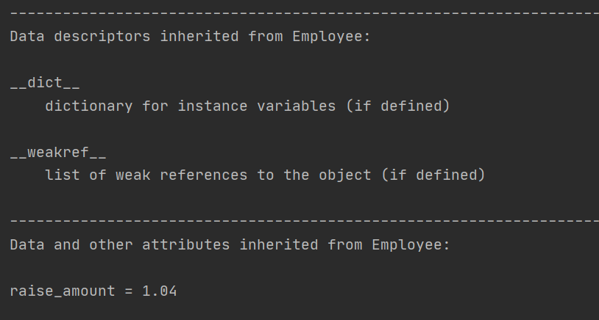
    - So take a look where it says method resolution order and then it says Developer, Employee, builtin.objects so what this means is that if you were to call something from the student class then it will go to the __init__ method in developer first and since there is no init defined then it goes Employee and if it wasnt in Employee then it will go to builtin objects ( now this basic in python its kind of like default) So now pay attention to where it says methods inherited from Employee such as init, apply_raise, fullname.
* So another thing that we are going to be talking about is the super function and the thing to know here is how to use it properly as suppose of using it the way i do.
  + 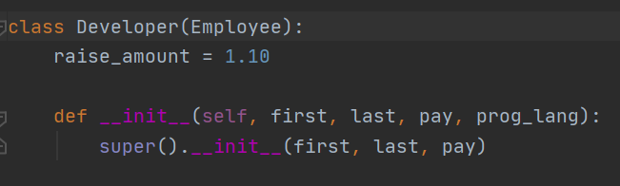
    - So take a look at this code we are using a super function and that is responsible for importing from the super class the thing to know here is that in the ( ) we are passing in first, last, pay. whenever i use super i just do super().__init__() and get everything and that goood but sometimes you dont need everything and you can specify what you want rather then importing everything. So here we imported first, last, pay
  + 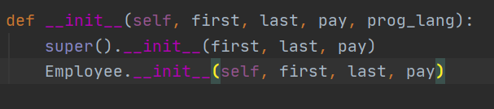
    - So take a look at this there is something else that you need to know here the second way of calling is also acceptable now the advantage of using it the second way as suppose to using the super is lets say you need to import from a specific class so the second one is saying Class Employee.__init__(self, first, last, pay) another thing to know when specifying what to import you need to attribute **self**. Now you might be wondering hey when are you going to every use this? lets say if you have so many classes but you dont want to import from everything therefore you can specify what you want imported from where it can actually be really useful later on.
  + 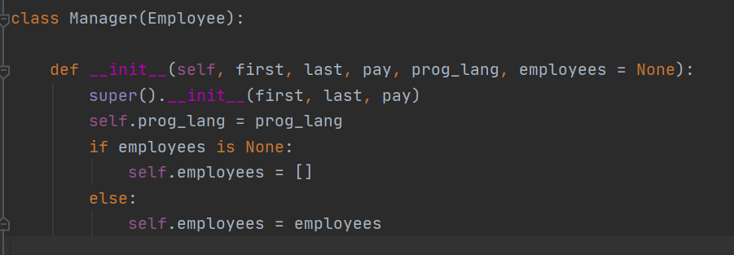
    - So first we have specified a class called Manager and we are importing from the Employee class and notice we are doing something here we are specifying employee = None this is something crucial because you might be wondering is why are we doing it this way? so the video didnt go into to much details of why doing it this way but the thing to know is that when it comes to list you NOT supposed to be putting list or dictionaries in parameters. The if and else statement is pretty self explanatory that if is none then list else self.employees = employees which is pretty simple. The level two question to ask is that when it comes to this programming in your code how can you incorporate this logic.

So now we are going to be doing some general notes for deeper understanding of the concept as suppose of learning just the syntax

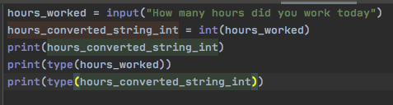

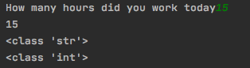

So take a look at this code as we can see that we are converting the input value which was string into an integer something that I wanted you to pay closer attention to was that was how we later defined the the input value to an int

Something that the book talks about is floating point and integer division 5/2 and the result is 2.5 and 5 // 2 is 2 and -5//2 = -3 So when It comes to python the thing to remember is that the double slashes when result is positive the fractional parts are trancuted and when negative they are then rounded this is something that might be important later on.

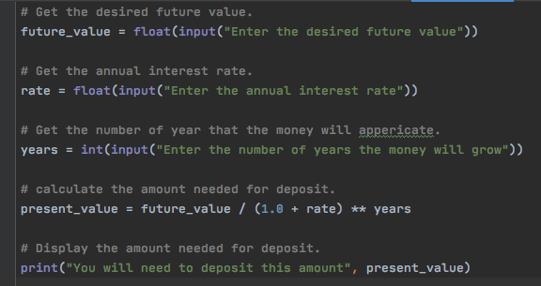

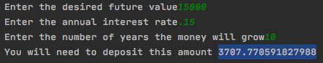

* So take a look at this like this is so cool because this is a finace formula that is calculating how much intial deposit you should have if you want your money to accrue over a given period of time at an annual interest rate.

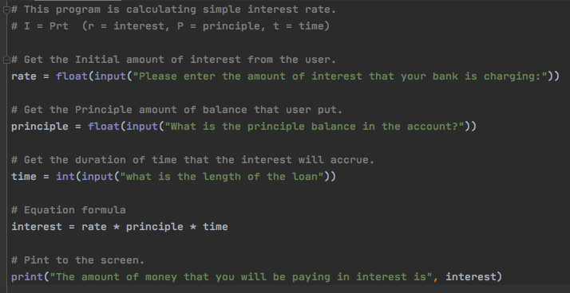

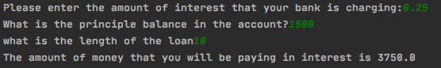

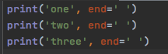

* So if you look at this code you can see that end= ‘ ’ This is telling python that hey be sure to print a space between these string and it will continue on the same line I thought it was like endl where the line gets terminated however that is not the case because this is just adding space. Another thing that is the most important thing to mention is that if you don’t want to create a new line after each print statement then you can use this end= ‘ ’ and if you don’t want space between each of the print statement then you can do this instead end= ‘’ notice how there isn’t any space between the semicolons.

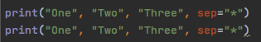

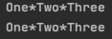

So take a look at this code the sep is just saying that hey be sure to separate the string by whatever that you place in between them. Something worth understanding here is that lets say if multiple things are on the print statement and you want a space or anything in between you can specify an item separator which main job is to either separate the strings from one another or not sperate them from one another. So, this code can also work had you said sep= ‘’ this would have just wrote each item in string together attached with no space **Each of the statements shown here display a string and then prints a newline character.**

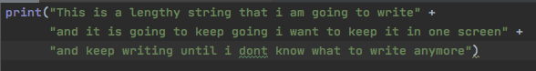

This is known as string concatenation which means that you can connect many strings with a simple + sign.

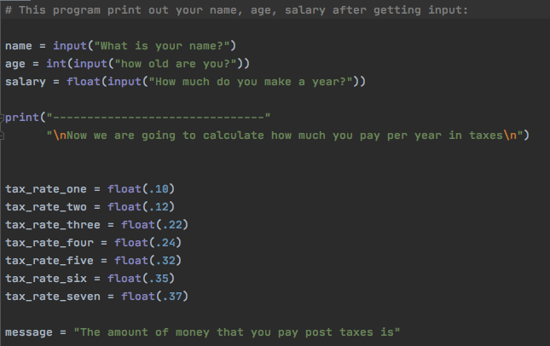

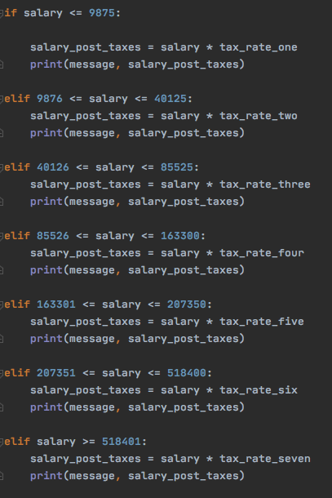

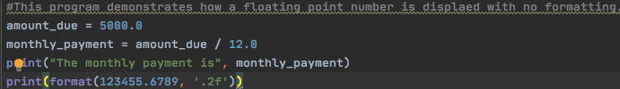

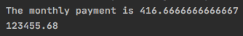

So take a look at this code something cool worth mentioning here is that this is the **format specifier** now you are wondering why are we going to be using a format specifier they are used lets say you have two floats dividing by another another you can use a format specifier because when you were to divide the two floats you would get a really larger float value in this case the 416.6667 etc and when you use a format specifier what you are doing is that you are rounding the value to whatever decimal place. An important point to mention is that you have to mention format(the number that you want to format, “.decimal valuef”



So here you can use e as well and this is for scientific notation the important thing to understand here is that “.2e”

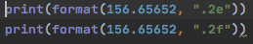

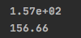

So take a look at this the cool thing about pyhcarm is that it lets you know what to put within the format( number , decimal and either float or scientific notation

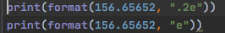

Something that I forgot to metion here is that you can either specify the decimal and scientific notation so whenever you were to see it as “.2e” then you know that is decimal value

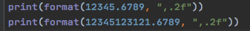

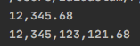

Something I wanted to make mention here is that this is the the same thing that we have been doing as you can see it is being rounded to 2 decimal place float value take a look infront of the decimal **IMPORTANT** here is the comma **,** infront of the .2 what this is doing is that it is putting a comma after every 3 numbers that is really important to understand take a look at the very first format

**Recap Notes over the stuff that I learned in Python!**

hours_worked = int(input("How many hours did you work today?"))  
print("You worked a total of ", hours_worked, "that is alot of hours that you worked!")

* So take a look here its pretty basic but notice how the int is being used in the input statement this is something that you need to know pretty simple tbh
* # Get the user name, age, and income.  
  name = input("What is your name?")  
  age = input("what is your age?")  
  income = float(input("What is your income?"))  
    
  #Display the data.  
  print("Here is the data that you entered:")  
  print("Name:", name)  
  print("Age:", age)  
  print("Income:", income)
* Take a look here pretty simple the stuff that we learned how we can use commas and the second thing here is that once again the income is set to a float
* # Assign a value to the salary variable.  
  salary = 2500.0  
    
  # Assign a value to the bonus variable.  
  bonus = 1200.0  
    
  # Calculate the total pay by adding the salary  
  # and bonus. Assign the result to pay.  
  pay = salary + bonus  
    
  # Display the pay.  
  print("Your pay is", pay)
* Here something that I learned was that they aren’t assigning floats and int you just are setting the numbers to the value in c++ you would be using those term identifiers. I think python is really simple in terms of that when you are storing the variable lets say in an input statement then you need to use int or float or lets say you are storing a value but you can just define the number into the variable because it will understand that there is a number that is being placed into the variable compared to having to tell the computer that hey this variable that is a number has to be predefined to be a number.
* Something that I wanted to make mention of was that when it comes to 5/2 your answer will be 2.5 its going to work basically like a calculator and if you wrote 5//2 you would get 2 because the decimal part gets removed this is different from module where the part doesn’t get truncated rather it looks at remainder.
* # Get a number of second from the user.  
  total_seconds = float(input("Enter a number of seconds: "))  
    
  #Get the number of hours.  
  hours = total_seconds // 3600  
    
  # get the number of remaining minutes.  
  minutes = (total_seconds // 60) % 60  
    
  # Get the number of remaining seconds.  
  seconds = total_seconds % 60  
    
  # Display the results.  
  print("Here is the time in hours, minutes, and seconds:")  
  print("Hours:", hours)  
  print("Minutes", minutes)  
  print("seconds", seconds)
* So take a look here this is more so of a thought process then anything but the first thing that you need to know is that you are going to be getting the total amount of seconds and thus the first thing that you need to convert is the number of hours we know deductive reasoning that 1 hour is equal to 3600 seconds thus if you divide the 11730 number that they used in the book with 3600 you are getting the number of hours which in this case is 3.25 and doing so what is happening is that the .25 is being removed because you are using the // this is finding the number of hours. The next thing that we are doing is that we are finding the number of minutes we first divide the 11730 by 60 because there are 60 which gives us the number of minutes so 11730 / 60 = 195.50 and doing so then you multiply the max value of 60 which is 60 * 3 = 180 and subtract it from 195 and you get 15 and that is the number of remaining minutes. So the only question that I had to myself was that why on earth are they using the % it doesn’t make any sense then it came to me where I was like oh they are finding the total time and then doing that well the answer is really simple to be honest the reason why they are doing it this way is because so once they find the total amount of minutes they need to see how much of the minutes are being left over and thus doing so that’s why they have 15 same goes for the second if there is 11730 seconds you have to see how many seconds are being left over from 60 and that is the total number of seconds which makes sense rather then multiply a value you are basically working backwards and keep clearing out 60.
* # Get the desired future value.  
  future_value = float(input("Enter the desired future value: "))  
    
  # get the annual interest rate.  
  rate = float(input("Enter the annual interest rate: "))  
    
  # get the number of years that the money will appericate.  
  years = int(input("Enter the number of years the money will grow: "))  
    
  # Calculate the amount needed to deposit.  
  present_value = future_value / (1.0 + rate) ** years  
    
  # Display the amount needed to deposit.  
  print("You will need to deposit this amount: ", present_value)
* Something that I didn’t really cover in the notes is that when it comes to int and float something that you need to do is that you can covnert the different data types so for example your variable can hold a float but you want to change it to an int you can thus proceed to change it to int by making a new variable with holding float value that’s been changed to int.
* ivalue = 2  
  fvalue = float(ivalue)  
  print(fvalue)
* So take a look here see how we are doing things here we are changing the int to a float pretty basic steps here.
* var1 = 1  
  var2 = 1  
  var3 = 1  
  var4 = 1  
    
  results = var1 * 2 + var2 * 3 + \  
   var3 * 4 + var4 * 5  
    
  print(results)
* So take a look at this code there is something that you need to make some mental notes here you can keep the prompt going with just / and keep adding the variables to one another.
* print("Monday sales are", monday,  
   "and Tuesday sales are", tuesday,  
   "and Wednesday sales are", wednesday)
* So take a look here same thing is being applied here what you are doing is that you are adding into the print statement so you don’t have to write an extra print statement for each line.
* **newline in python**
* print("One", end=" ")  
  print("Two", end=" ")  
  print("Three")
* This is hard to tell but the thing to know here is that you are putting a space between these print statement the code will not pass a new line and thus print these words on the same lines
* 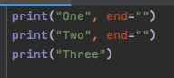

* Take look here the thing to know is that the print statement has end=”” and there is no space between the quotation marks thus there will be no space being printed between the words Something worth mentioning here is that when it comes to this this is a lot similar to the stuff you learned in c ++ where you specify for the endline and how you can manipulate the print stuff on the screen.
* **Specifying an Item Separator**

* 
* So take a look at this code here the same thing here now the only thing to know here is that one two and three will all have * between them
* 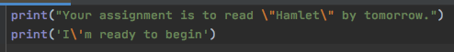

* So this is pretty cool you can use \’ or \” within your line of code in order to write quotation marks around it.
* 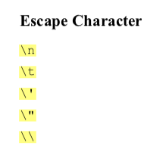

* So these are different escape character pretty simple in my opinion.
* 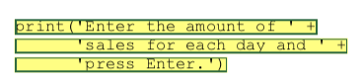

* So this is string concatenation at its finniest its basically adding different string to each other so you are just adding a bunch of string together.
* **Format Specifier**

* So the next thing that we are going to be talking about is the format specifier this is a string that contains special character specifying how the numeric value should be formatted.
* 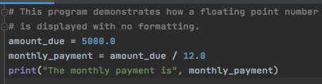
* 
* So take a look at this here since we are doing division python likes to give your answer in like 12 decimal places and you cant have this so in thus you can use a format specifier.
* 

* 

* So take a look at this code you can see we are using a format specifier and here the second part is a string value where you are labeling the .2 is the decimal places and the f specifies that the data type of the number we are formatting is a floating point number.
* 
* 

* So take a look at this code as you can see that we are using a string with a format specifier you can see later on how useful this thing can be.
* 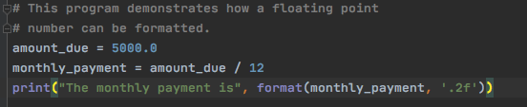

* 

* So take a look how the format specifier is being used here the variable that is holding our calculation is being formatted. This is something that you need to know of what is going on.
* 

* 
* 
* 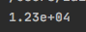
* So take a look here you can see that we are using the format operator with the letter e doing so what this means is that we are using scientific notation the e is basically telling python that the number that you are working with is an exponent.
* **Inserting comma separators**
* 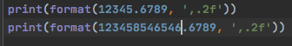
* 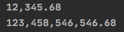
* So take a look here this is something that I found that if you were to put a comma between the ‘ and the .2 what this is going to do is that its going to be putting a , between all the numbers in terms of places to 3 and makes the number more readable.
* 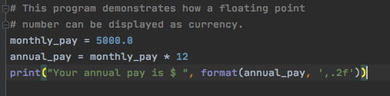
* 
* So this is an accurate description of how this would work notice how the variable that is storing the numbers is being used here and then the syntax of how its being set up.
* 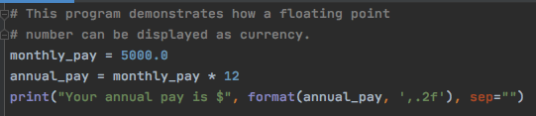
* 
* So this code really isn’t that complicated the thing that you need to know here is that since you are working with formatting a variable in doing so your adding the sep and this is separating the space between the $ and the variable this program is teaching that you can add the sep with the format variable so you can basically write it all in one line important concept to remember here is that you are working with the space that is between the $ and the variable.
* 
* 
* So as you can see here there is the 12 and this is saying that the 12345 need to be spaced 12 spaces. For some reason the code doesn’t seem to be working well but the idea that they are preaching is that by writing 12 you are stating the width of how many spaces the , says that be sure to put a , in right value and the .2f is saying that be sure to round it 2 decimal places.
* **The Turtle**
* So the next thing that we are going to be covering in python is called the turtle now this is something that is new to me
* 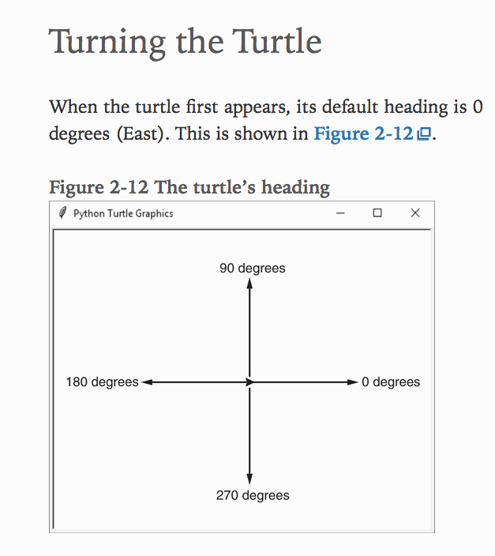
* So this is kind of cool this is the graph that we learned in trig it showed that how the unit circle is calculated and the thing to be aware of this is that we are using the turtle to move in this so for example
* 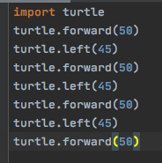
* 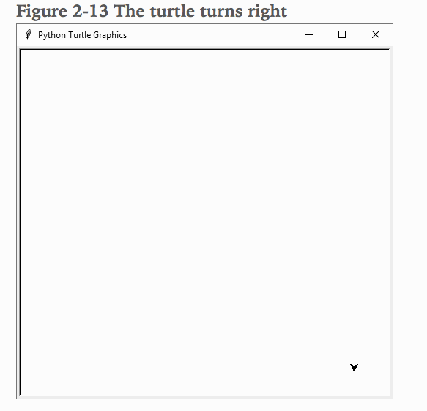
* So the thing to learn from here is that turtle forward is moving the turtle to the fron and the left is basically moving it at an angle so the idea here is that the turtle is always going forward however it will be moving on angles.
* 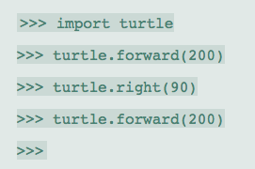
* Look here you can see that the turtle is moving on an angle of 90 and going forward. Something that I had forgot to mention here was that when it come to the right and left here we have to tell the turtle to either turn right or left which is understated but in the next line of code you can see how it can be applied and how the code changes.
* 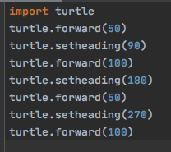
* 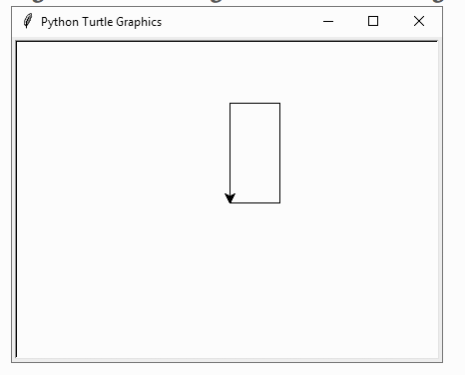
* So take a look at this code for the box the thing to notice here is that the setheading is different from the right and left the best way to think of it is that right and left is basically telling which direction for the turtle to turn and the setheading is basically used for turning the turtle by itself no need to turn it all. The best way to think about this is that the turtle turns by itself then goes which is about it.
* So the next thing that we are going to be talking about is the turtle penup and pendown and the thing to know here is that it sounds like way it is keeps writing and then pick pen up doesn’t write.
* 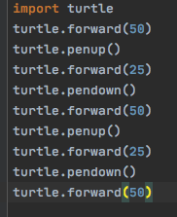
* 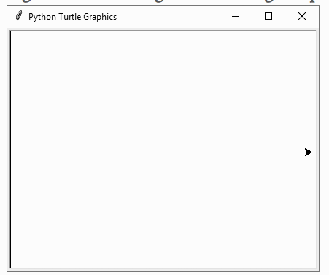
* So the next thing that we are going to be talking about is the turtle.dot this is self explanatory as well because the thing that is happening here is that the your just making a dot.
* 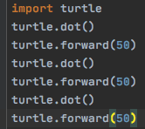
* 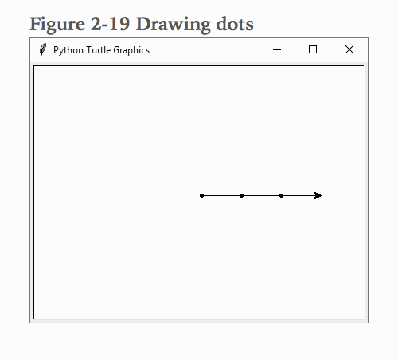
* 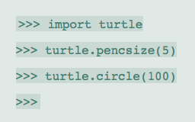
* This is how you were to use the turtlepensize and the 5 is changing the width of the pencil.
* 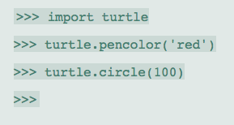
* 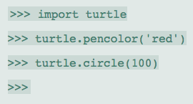
* 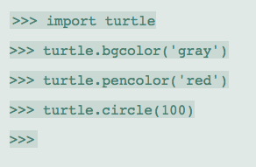
* 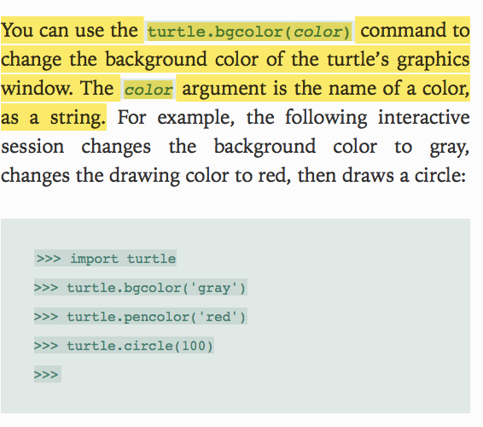
* 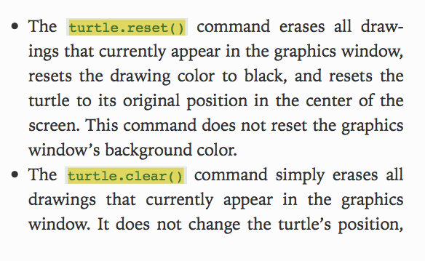
* 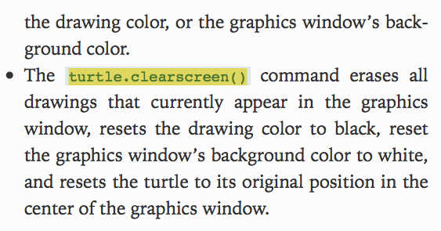
* 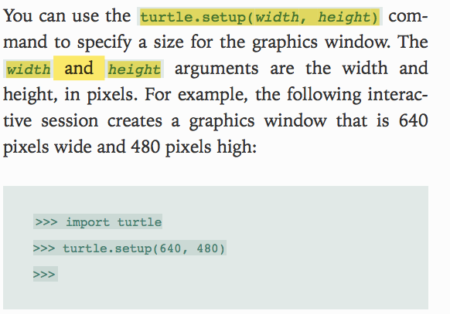
* 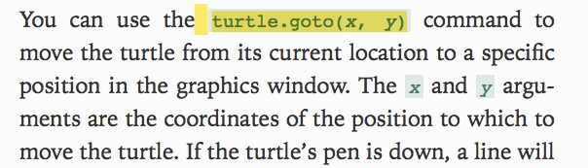
* 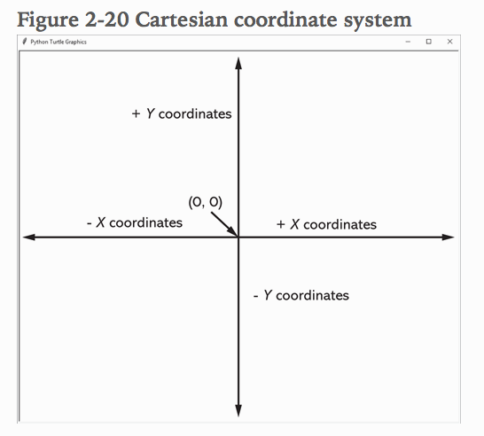
* So something to mention here is that when you see the number in the code such as turtle.goto(X,Y) whats happeining is that you labeling points on the graph and the thing to consider is that the points within the ( ) are coordinates of the length, width
* 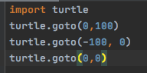
* 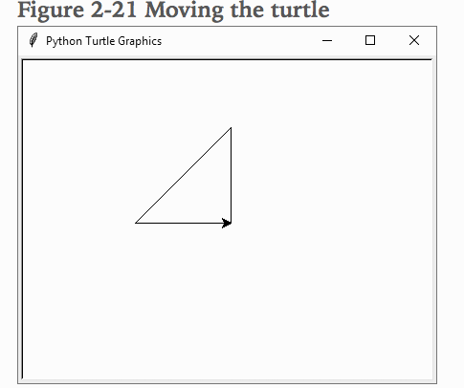
* So notice how in this code it is covering the concepts that I am talking about it goes to Something else that I caught on to was that the first point that it is starting with the vertex over the 90 degree but it is going to that vertex then the point that is adjacent to the vertex and thus returning to the 90 degree the reason why this is important is because it shows the code is being run the way to think of it is as there are 3 different stops in which the code must travel to and when they do it forms a picture so the count is only 3 coordinates not 4 like how I was doing.
* 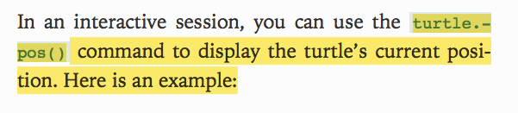
* 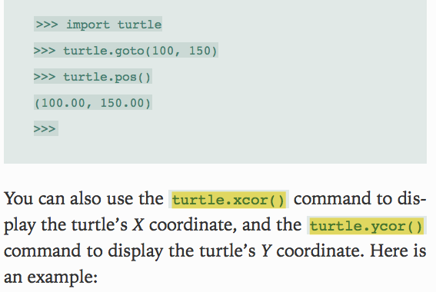
* 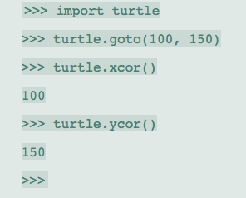
* This code is self explanatory however the one thing that I had found quite particular was that this code you aren’t setting it you are just stating the number on the bottom for the x and y coordinate.
* 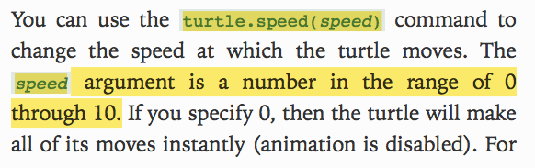
* 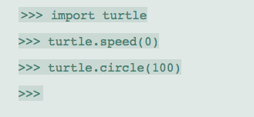
* So this is implying that if you were to just type in 0 then the circle would be displayed really fast
* 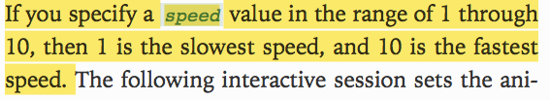
* 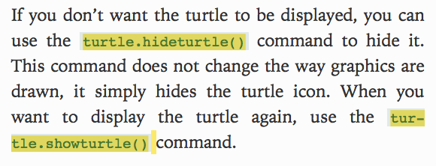
* 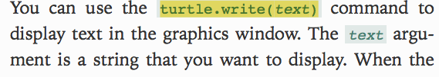
* 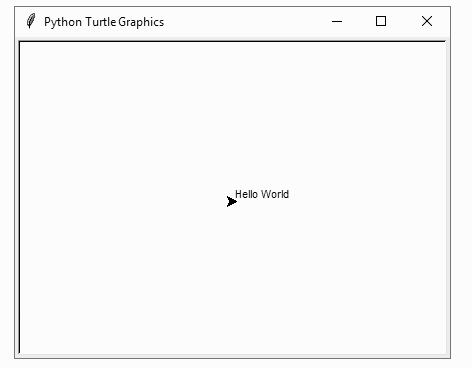
* 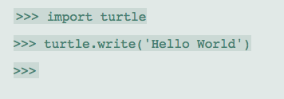
* 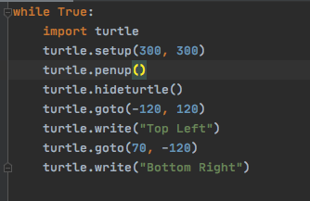
* 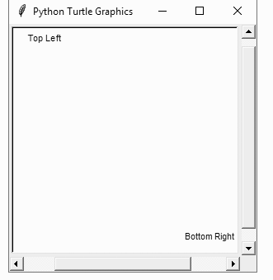
* So lets take a look at this code as you can see we are using the things that we learned about this stupid turtle the very first thing that I wanted to point out was that we are using a while loop doesn’t say it in the book but reason why I did it was because the window wouldn’t stay so I just used a loop the second thing that I wanted to mention was that this code is self explanatory except one part which was the turtle penup I was like what the heck is the reason for this part of the code well answear is really simple the pen keeps marking unless you tell the pen not to mark till it gets to this point then it will not work. Other wise it will work here is how the code will look when the pencil isn’t picked up.
* 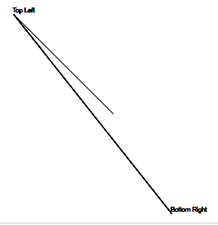
* 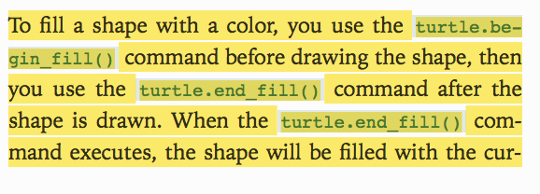
* 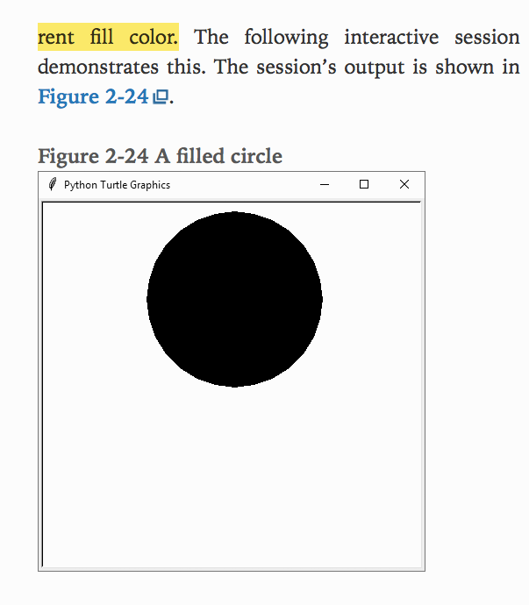
* 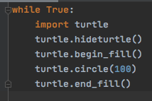
* So take a look here you can see that the we started begin fill before we entered the radius then ended after the radius had you not done this way you would have just gotten the circle drawn my theory is this that when you are stating a begin fill what you are doing is stating when to start and then when you put end fill you are stating when to stop.
* 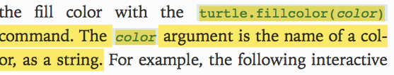
* 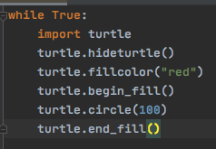
* 
* Notice how we are defining the color first then begin the fill specify the radius and thus end the fill this is something that you need to be aware of.
* 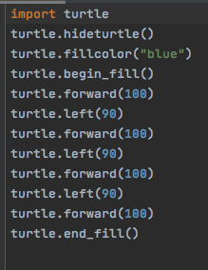
* 
* So this is pretty simple here as well you are just drawing a square the only problem that I encountered that I kind of was like wow was that I was using a while loop so the code can be on screen for long time however because of that the program kept making squares and stopped at 4 this is a logical error.
* 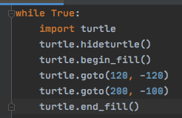
* 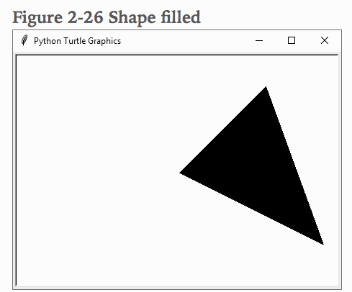
* So take a look here as you can see that the shape is being filled out the best way to think of this is think of trigonometry where you are just thinking of the graph the coordinates and thus plotting the points. One thing that really stood out in this code for me was that the bigger picture was that when you are specifying the points you are doing more than just labeling some points rather what you are doing is labeling a quadrant the best way to think of this is when they bomb an area they are specifying the points and everything within the points needs to be destroyed that is what is happening when you are putting begin fill and end fill your are specifying parts within the quadrants.
* 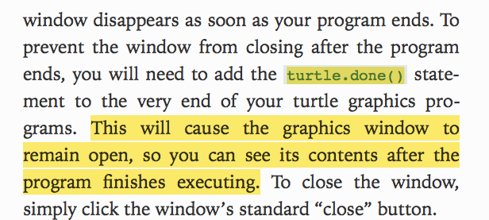
* **Chapter 2**
* 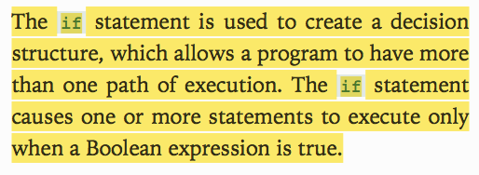
* 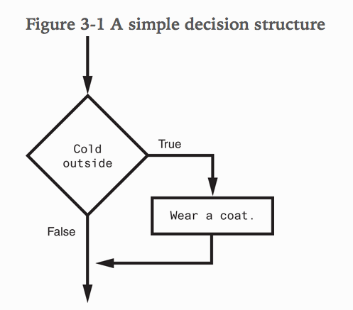
* These are concepts that are covered in C++ here of how the decision structure works.
* 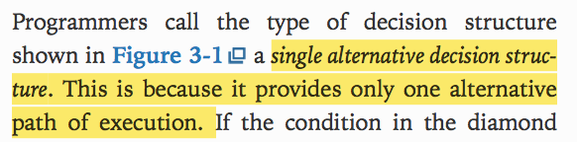
* 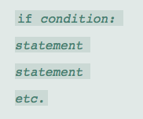
* 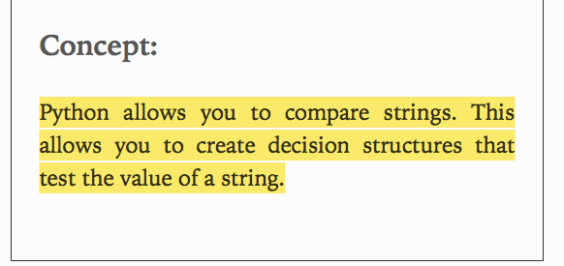
* So as you can see that I am not really taking to much notes on if and else statements however the thing that caught my eyes was comparing string I was like what is so special about this? Well lets say you need to compare two names or lets say a username that you write and compare it with the other username that you have then you need to compare the string to make sure that they are the same thing and all.
* 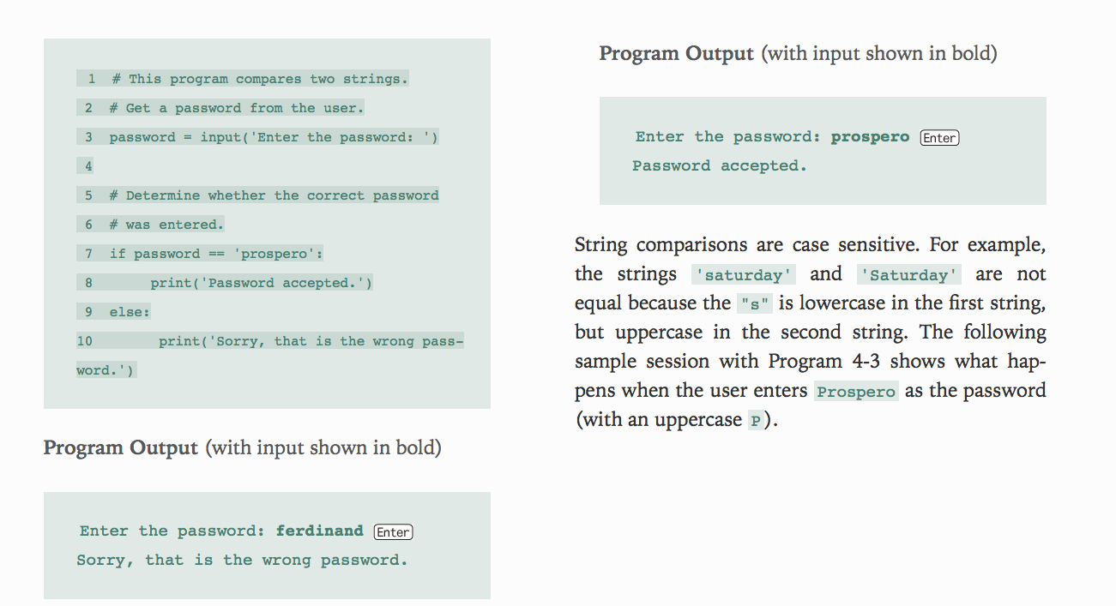
* This code summarizes what I was saying.
* 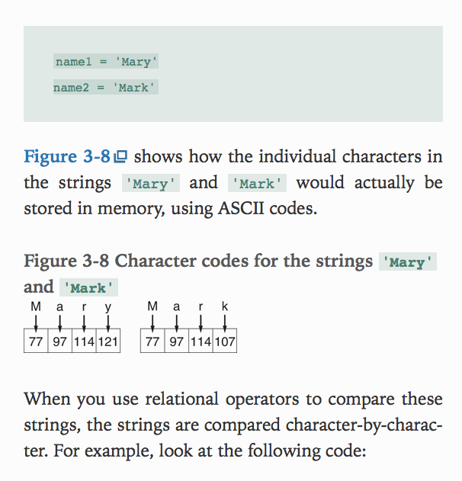
* 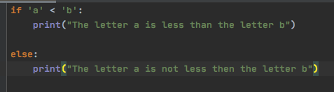
* Notice how the string of the if an else is setup the thing I wanted you to be aware was notice how in C++ the thing that was happening here was that after each cout statement there was ; here the print statements don’t have the such thing however the conditional statements have : which I thought would be easier to remember.
* 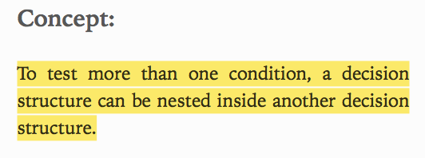
* 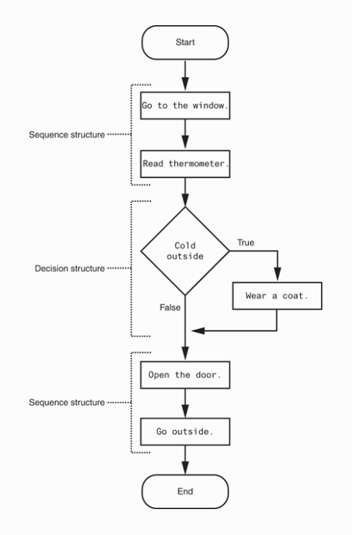
* This is really hard to read but the idea behind is how so many decision are made and thus structured out take a look here notice how it starts with sequence structure and in the middle is the decision structure this is the part where your program is going to make a turn think of it as a car driving on the highway and it stops and sees two different road it needs to know which road to take that is best for it. Something to know is that this is just a simple if and else statement often times you will be using nested decision structures.
* 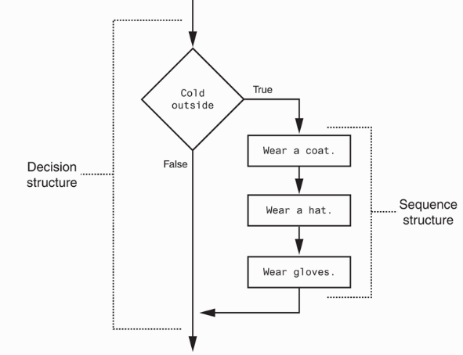
* Take a look here this is what a nested decision structures looks like this adds to the program where you can write several lines of more conditions within the conditions. I learned that the best way to describe this is circles within circles you will see in the next line of code.
* 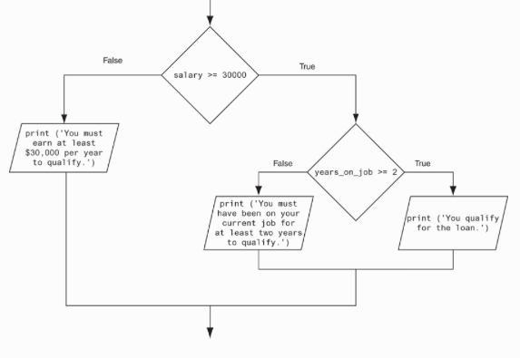
* 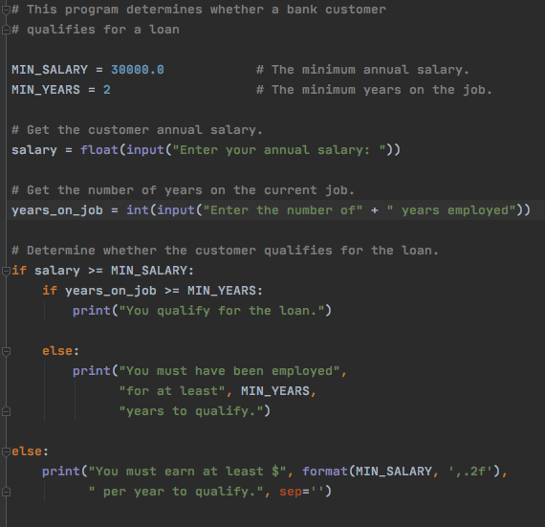
* So in this code there is a lot that is happening but the thing first to know here is that code is an example of decision structures something that caught my eye right off the bat was the second else statement had I written the code I would have written the first else condition knowing that it is going to be nested. So to break down this code first we are starting with the variables that are preset that is the easy part the second thing that we need to know is that we are defining the variables and something cool that I relearned here was that notice how we are defining the variables here as int and float this was a question that I had earlier where I was thinking to myself that how come we aren’t setting the initial variables that are already predefined to their number the thing to know here is that the ones that you are taking from the person need to be predefined because python doesn’t know those variables that’s coming from the user therefore you must define them. The next part is when it comes to the decision loop is structured your basically telling python that hey if these two decision structures are right thus you are qualified the thing that came to my mind was that you can prob write this with and or but statements which will make the code easier to read. The next else statement here is basically used to state if the condition if the first condition is not met where salary is less then amount its kind of like gpa if you don’t meet the marks then the were sorry but you cant be here. The last thing to know here is that pay attention to the formatting notice how the string are being written they are just being added some have , within the print statement. Another thing that really caught my eye was that when it comes the last else statement we are using the format( ) here the thing to remember is that we are formatting the variable that we want in this case the min salary two decimal places and thus putting a comma and the reason why we are using the sep = ‘’ we will take a look at this in more detail pay attention to the next code.
* 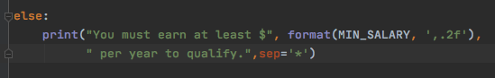
* 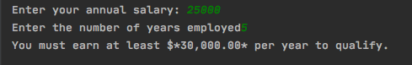
* Take a look here now you can see the bigger picture notice how the sep is working its working like a sandwich there are two string literals on each side in the middle is the format by doing so what is happening is that its formatting a space between the string literals that is why we added an extra at the per.
* 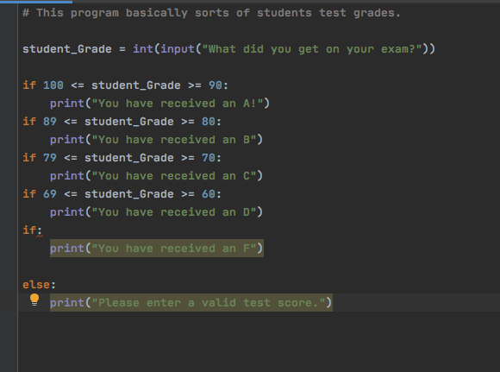
* 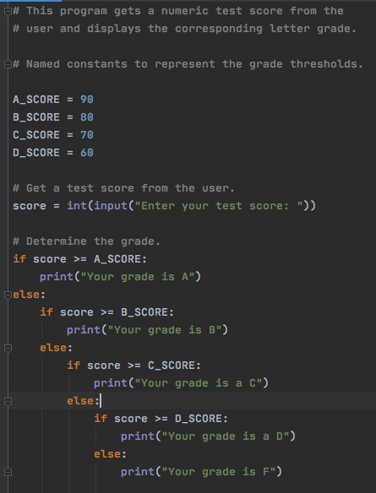
* So take a look here the thing that got me mad was that I didn’t think of the decision path as a staircase where its like backup planning and the funny thing is I took really detailed notes on this where I was talking about decision structures where its either else if and so on the best way to remember this is think of the elif clause the reason why that is important because that is more simpler to understand and easier to write this is like in the else statement you are writing another if statement and it becomes like a staircase going deeper the thing to understand here is that when it comes to this imagine if you had to write 1000 if and else statements that would take a toll on you.
* 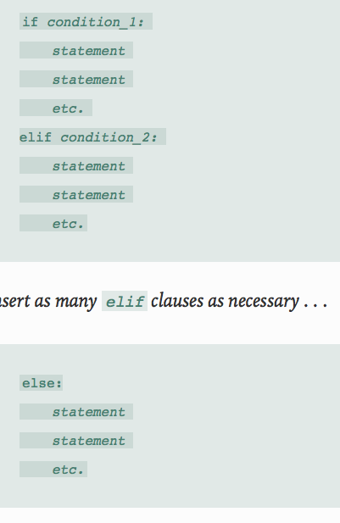
* 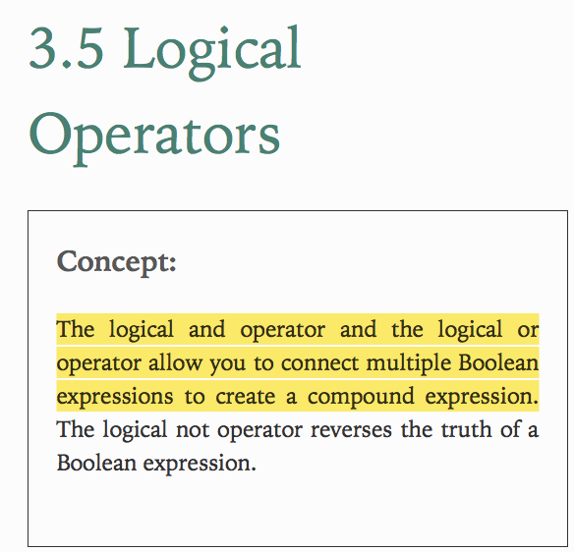
* 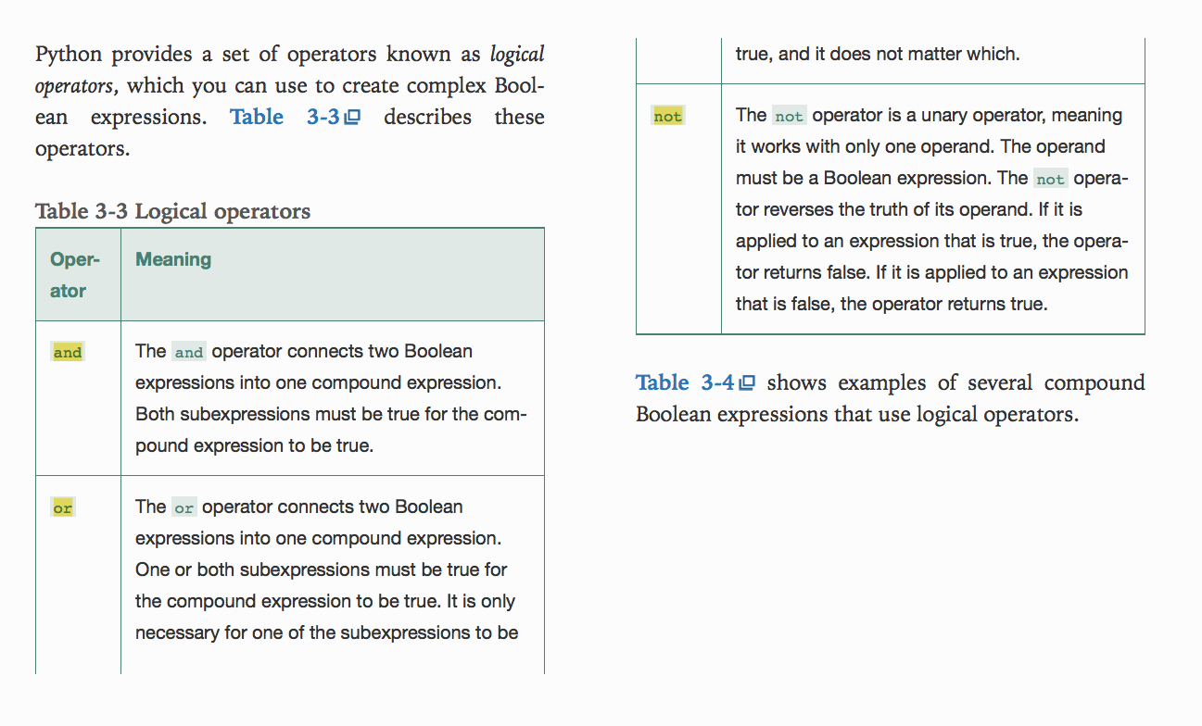
* 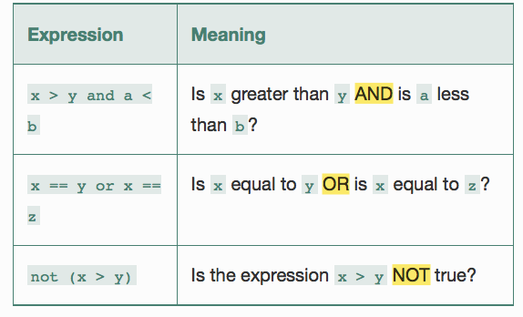
* So take a look here you can see that this is stuff that we already covered but the idea behind it is that you can use these operators
* 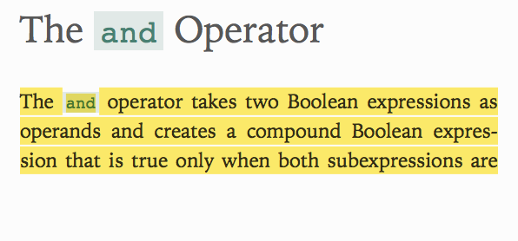
* 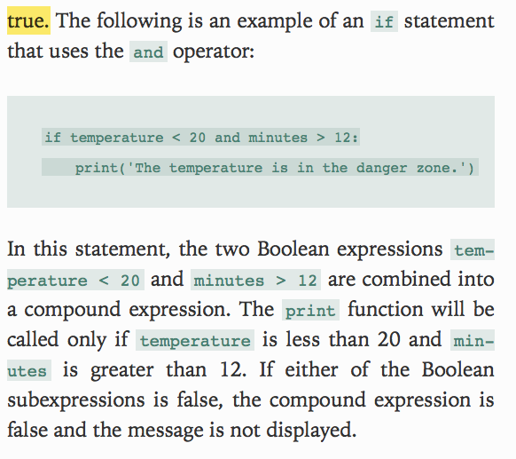
* 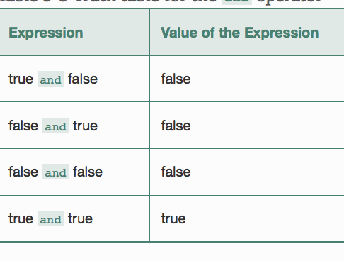
* 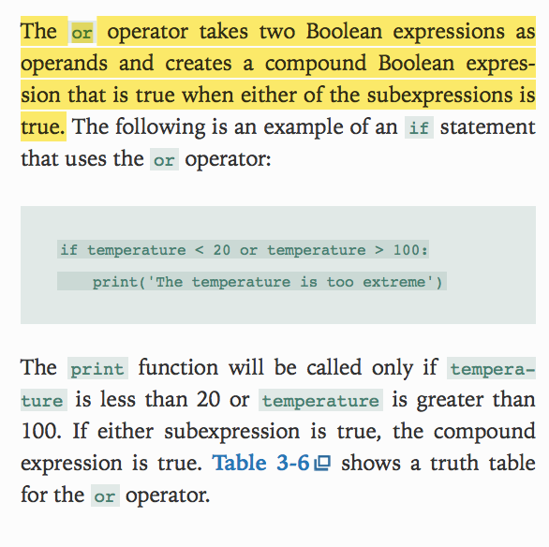
* So the and operator is really simple to understand that both subexpressions need to be true but the thing that caught my eye was when it comes to the or operator notice how it is either or is true then the expression runs its fairly simple to understand but I was just wondering how it would look like in an if loop. The thing to know here is that this will run the print statement if the temp is less then 20 or greater then 100 that’s what I was thinking like how do you know when the thing is going to run the condition.
* 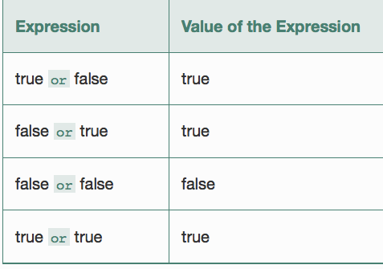
* 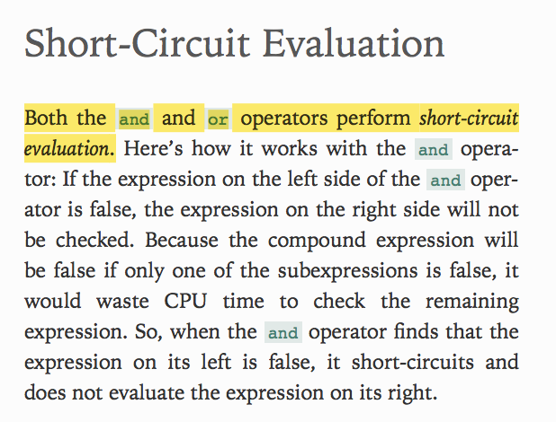
* This is kind of cool because when it comes to short circuit programming the thing to be aware of is that when these two expression are checked and lets say if it is an and being used then one statement is false then the whole thing becomes false best way to remember this is that think of and, or as high tempered b@#@ where they will be like only listen to half of it and then reach the judgment.
* 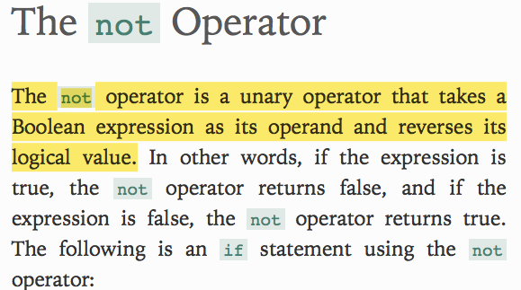
* Take a look at the next line of code it will make more sense when you see it in perspective.
* 